

**RBP Guest Inquiries**

**Administrator Guide**



Version 3.1

WELCOME

Congratulations on your decision to implement RBP Guest Inquiries; the next step in guest inquiry automation. Because your time is very important to us, we at RBP Software Solutions have designed a system that's both user-friendly and efficient.

To help get you up and running on the system quickly our training manuals have been designed to complement our personalized training sessions. In this Administrator Guide, we'll walk you through the steps necessary to customize your system and register users. You may view the Guide in its entirety or skip to the sections most important to you and your property.

With that said let’s get started!

ACKNOWLEDGEMENT

The RBP Guest Inquiries Administrator Guide for Property Administrators was developed by RBP Software Solutions. The RBP Guest Inquiries program is operated by RBP Software Solutions. RBP Software Solutions owns, publishes, and maintains the RBP Guest Inquiries training manuals and related publications. Technical support for the development of this document was provided by regional associates and technical resources. Every reasonable effort has been made to ensure the material presented herein is up-to-date and accurate.

NOTICES

RBP Software Solutions has made every reasonable effort to ensure the accuracy of all the information contained in this publication and other publications in the RBP Guest Inquires Program. However, RBP Software Solutions makes no representations or warranties whatsoever whether express or implied as to the accuracy, correctness, currency, completeness or fitness or suitability for any purpose of such information and therefore disclaims to the maximum extent permitted by law any and all liability for any error, damage, loss, injury or other consequence which may arise from use in any manner of any information contained in this publication. This document is intended to provide general Administrator guidelines for the electronic access and handling of the RBP Guest Inquiries Software. The contents of this publication are property of RBP Software Solutions and must not be reproduced in whole or in part in any manner, including in print, online or by other electronic means, without the permission in writing of RBP Software Solutions.

© 2017 RBP Software Solutions

Administrator Guide, Content, and Design licensed by, and property of, RBP Software Solutions. www.RBPsoftwaresolutions.com

Table of Contents

Administrator Registration 4

Account Set-Up 5

Solution Log In 6

Customize The System 7

Associates Tab: Creating User Profiles 8

Registering Users 8

Registering Individual Associates 9

Processing Authority 10

Authorities Defined 11

Ticket Assignments 12

Inquiry Notifications 13

Re-Sorting the list of Associates on the Main Page 17

Re-Setting Passwords, Editing Registrations, and Deleting Associates 17

Group Logins Tab: Creating a Group Login 20

Group Logins 20

Departments Tab: Selecting/Deselecting Departments 25

Customizing Departments 25

Inquiry-Types Tab 30

Customizing Inquiry Types 30

Customizing Inquiry Types with an Optional Sub-Description 34

Properties Tab 37

Customizing Guest Emails and Editing Property Information 37

Guest Emails 40

Verifying Inquiries by Sending "Internal Emails" to Department Contacts (optional) 45

Setting up Internal Communications for Department Groups 45

Setting Up Approvals 51

Credit Limit Examples 52

RBP Software Solutions 54

Our Commitment to Customer Satisfaction 54

Administrator Registration

Section 1: Registration

As the new RBP Guest Inquiries System Administrator, you will become your property’s RBP System Professional.

*Section 1: Registration* will walk you through creating your new username and password.



Account Set-Up

As the **Administrator** in RBP Guest Inquiries you will **register users** and **customize your site**. This is done through the "**Administrator Tab**" on the Main Menu. As the Administrator, you are the only system user to have this tab.

We will set you up as the Administrator during installation. When you’ve been set up you will receive an email from the system prompting you to create a password (see below). To ensure email delivery, please add <**noreply@rbpsoftwaresolutions.com**> to your safe-senders list.

When received, please click the **password link in the email** to complete your registration as shown in Figure 1.1:

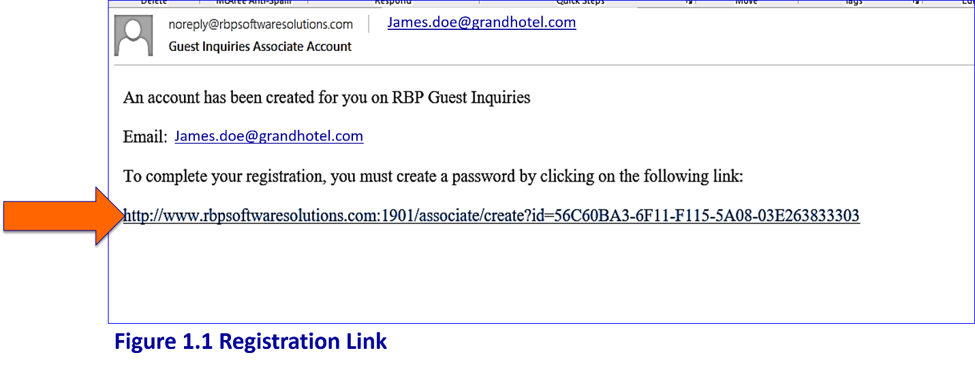

Figure 1.1 Registration Link

|  |
| --- |
| **NOTE** |
| If you do not receive the email, please check your **"junk"** folder as it may have gone there. If it is not there, contact us and our support team will resend the email. |

Solution Log In

After you've created a password your registration is complete. To **login** you will **access the site using the link below**. Please save this link and access the system using the steps shown in Figure 1.2 below:

1. **Go to:**  <http://www.rbpsoftwaresolutions.com>
2. **Enter:** Email
3. **Enter:** Password

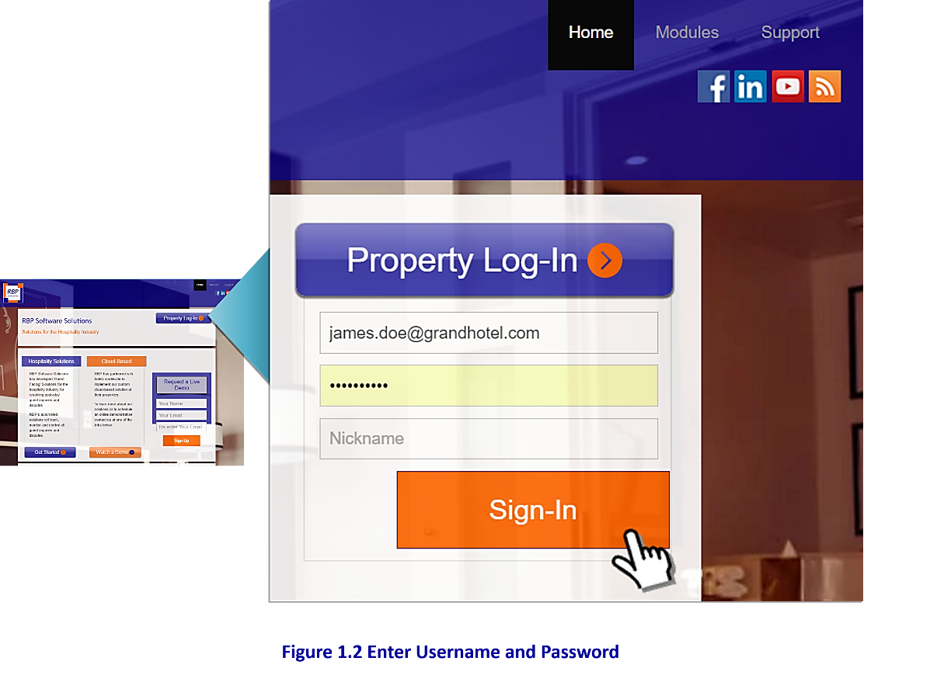

Figure 1.2 Enter Username and Password to Log-In

|  |
| --- |
| **NOTE** |
| Please add **<http://www.rbpsoftwaresolutions.com>** to your favorites list to allow easy access to the guest inquiries solution. |

Customize The System

Section 2: Associates, Groups, Properties, Departments, Inquiry Types

With RBP Guest Inquiries you may choose to set up associates as either *Individuals* or as *Groups.*

A *Group Login* is especially helpful if a department (i.e. the Front Desk) will help to process inquiries.

Up to five people may log-in at the same time using a group login.



Associates Tab: Creating User Profiles

Registering Users

In the sections to follow we'll walk you through registering both *Individual Associates* and *Groups*. Prior to registering anyone, however, please **ask all registrants** (*Individuals* and *Groups*) to **add** <**noreply@rbpsoftwaresolutions.com**> to their safe-senders list. This will ensure they receive the email from the system prompting them to create a password.

After the password has been created, each user should **log in to the system** using the link below:

**http://www.rbpsoftwaresolutions.com**

**Add to Safe-Senders List to ensure delivery of system email to create password:**

**noreply@rbpsoftwaresolutions.com**

**Add Link to Favorites to log into RBP Guest Inquiries:**

**http://www.rbpsoftwaresolutions.com**

|  |
| --- |
| **NOTE** |
| If a registrant **does not receive the password email** from the system (and cannot find it in their junk folder), you should simply "**reset their password**" as shown later. This will prompt the system to resend the password link. |

**Registering Individual Associates**

To set up individual users, select the “**Administrator**” tab from the main menu and the “**Associates**” tab from the submenu as shown in Figure 2.1:

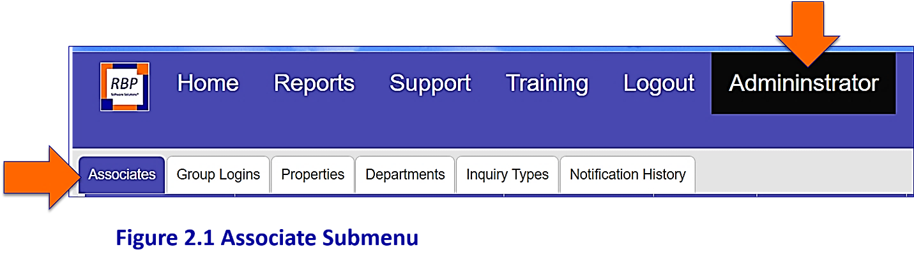

Figure 2.1 Associate Submenu

Click on “**Add Associate**” in the lower left corner of the screen as shown in Figure 2.2:

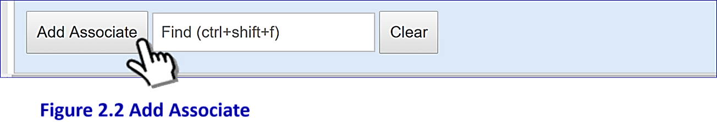

Figure 2.2 Add a New Associate

|  |
| --- |
| **NOTE** |
| To return to the **Main Page** at any time without saving changes simply select the **“Cancel”** button. This works on all of the tabs. |

The Add Tickets button will lead you to the registration page shown in Figure 2.3. Enter the associate information into each box and click the dropdown arrow next to "**Title**" to enter the Associate “**Title**”:

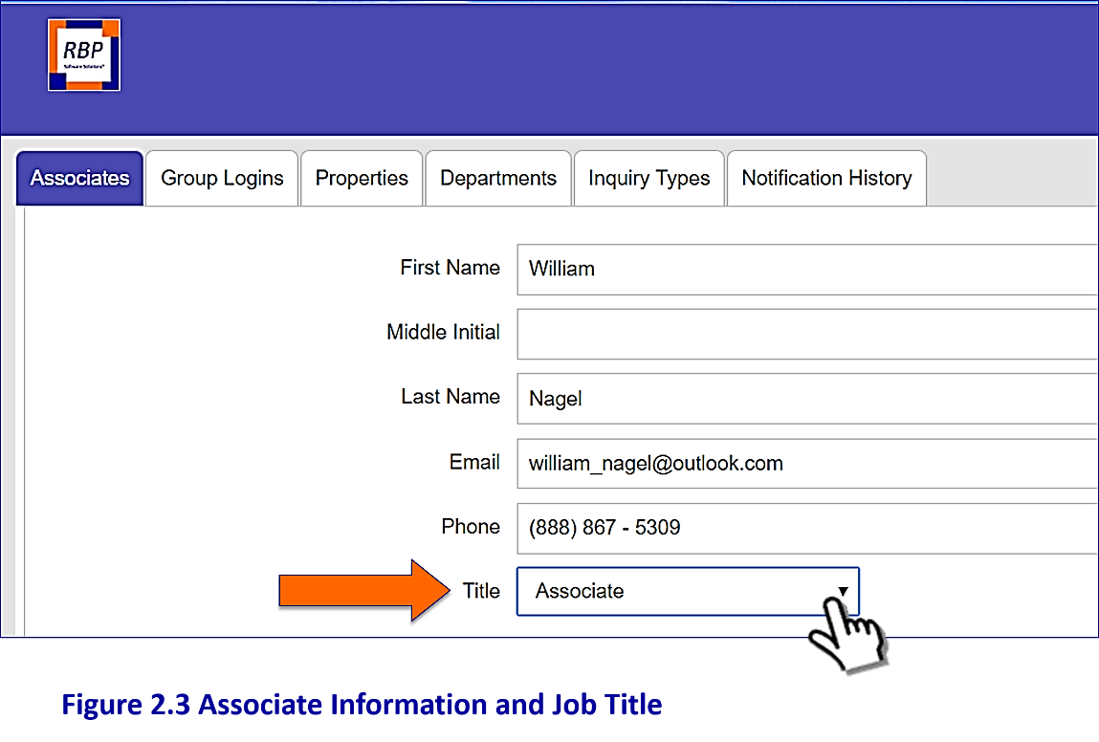

Figure 2.3 Associate Information and Job Title

Processing Authority

After filling in the descriptive information, you are asked to assign each registrant a “**Processing Authority**” from the list shown in Figure 2.4. The Processing Authority simply tells the system what kinds of inquiries the registrant is allowed to process. The “**Authorities**” and their duties are defined below. To assign an “**Authority**” simply select the appropriate cell.

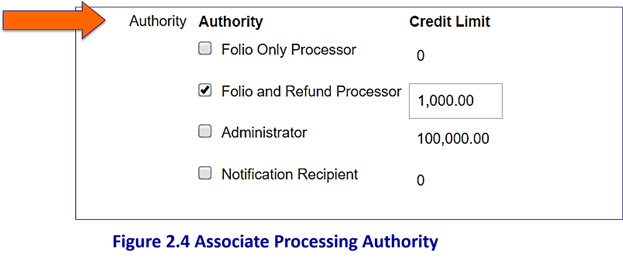

Figure 2.4 Associate Processing Authority

**DO NOT** assign the “**Credit Limits**” for now – we'll discuss Credit Limits later in this module.

**Authorities Defined**

Folio Only Processor – This is a user who will only process folio and receipt requests; he/she will not process refunds/credits or any other types of inquiries (often used for front desk users).

|  |
| --- |
| **NOTE** |
| If a **“Folio Only Processor”** attempts to process a refund, that inquiry will need to be approved by someone with a higher credit limit. See the “**Approval Process”** section later in this module. |

Folio and Refund Processor– This processor will have authority to process folios, refunds and any other kinds of inquiries. Most accounting personnel will be given this authority.

Administrator– The Administrator may register users, reset passwords and customize the system. He/she may also process all inquiry types. You may set up alternate Administrators if desired.

Notifications Only Recipient – This person will not process inquiries, but will be set up to **receive Status Reports** from the system.

|  |
| --- |
| **NOTE** |
| **Notification Recipients** will receive monthly status reports from the system on (or about) the fifth of the month. You may also send "**On-Demand**" status reports as desired. **Best Practice** is to inform General Managers and Regional Managers on how many billing inquiries you’re receiving and processing each week. |

Ticket Assignments

When registering Associates, the Administrators can adjust the Ticket Assignment List in the “**Associates**” information page, below Processing Authority.

|  |
| --- |
| **NOTE** |
| The “**Assign Associates**” dropdown menu is located beneath the “**Departments**” box on the inquiry page. By default, all Users' names will appear on the “**Assignees**” dropdown list of potential inquiry assignments. |

To remove a user from the assignment list, scroll to the "**Ticket Assignments**" box and select the "**Exclude from ticket assignments list of associates**" box as shown in Figure 2.5. To keep the associate ON the Assign Associates dropdown menu, **leave this box unchecked.**

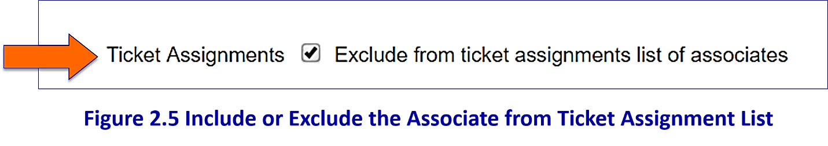

Figure 2.5 Include or Exclude the Associate from Ticket Assignment List

**Inquiry Notifications**

Next, the Administrator is prompted to select which “**Inquiry Notification(s)**” each new associate will receive. The Administrator is responsible for assigning inquiry notification alert-types during the new-employee set-up process. Inquiry Notifications are email alerts which are sent to associates to alert him/her of new inquiries and status updates in RBP Guest Inquiries. You may select as many of the options as you wish (or none at all) as shown in figure 2.6.

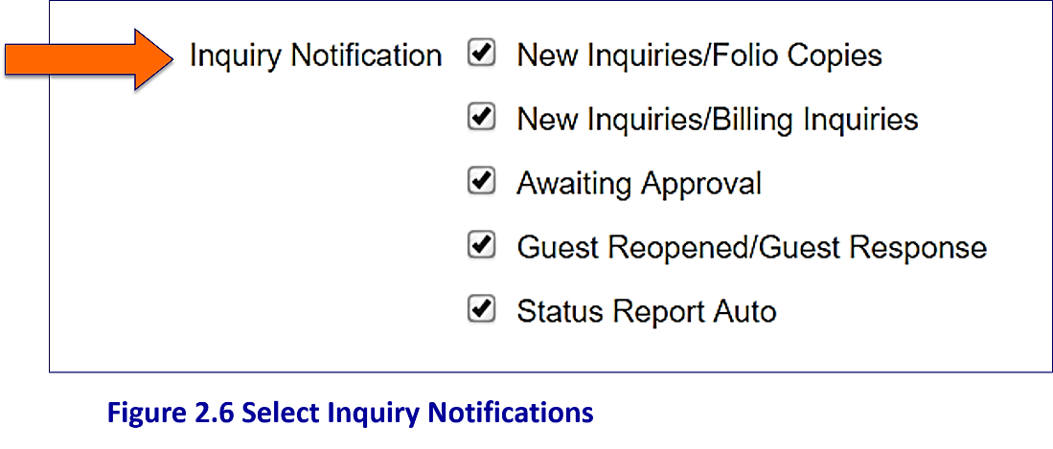

**Figure 2.6 Select Inquiry Notification Alerts**

The first notification "**New Inquiry/Folio Copies**" will send an email alert for new folio requests only**.** The second option “**New Inquiries/Billing Inquiries**” will send an email alert for each new billing issue, not for folios. These email alerts contain a date stamp and a **link** **directly to** the inquiry as shown in Figure 2.7 below:

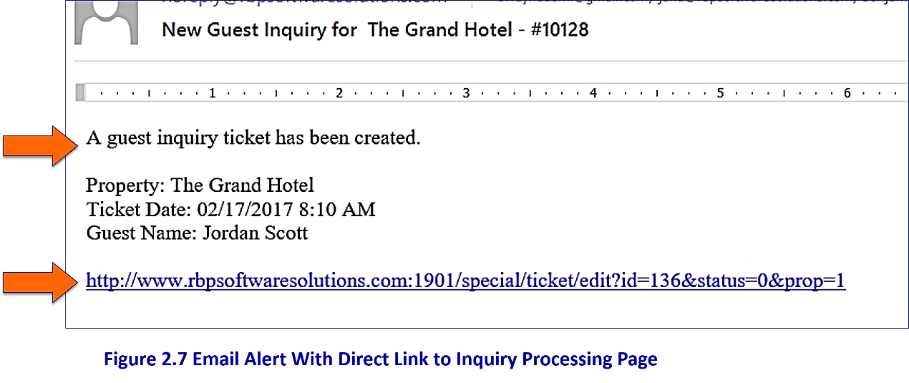

**Figure 2.7 Email Alert with Direct Link to Inquiry Processing Page**

The “**Notification Options**" that generate the greatest number of email alerts are “**New Inquiries**.” The Inquiry Notification option for "**New Inquiries**" is split into two categories:

* “**New Inquiries: Folio Copies**”

**AND**

* "**New Inquiries: Billing Inquiries**"

This split will allow **Folio-Copy Processors** to receive notification emails for **folio requests only** and not for all the other billing issues. The second **new inquiry** option “**New Inquiries:** **Billing Inquiries**” will send an email alert for each new billing issue request, not for folios.

|  |
| --- |
| **NOTE** |
| To streamline inquiry processing, your property might consider assigning Front Office Associates with "**New Inquiry/Folio Copies**" to receive notification email alerts for **folio-copy** requestsand the Accounting Associates to receive “**New Inquiries/Billing Inquiries**" notifications. |

If you'd like the new associate to receive notifications for both, simply select both options as shown in Figure 2.8:

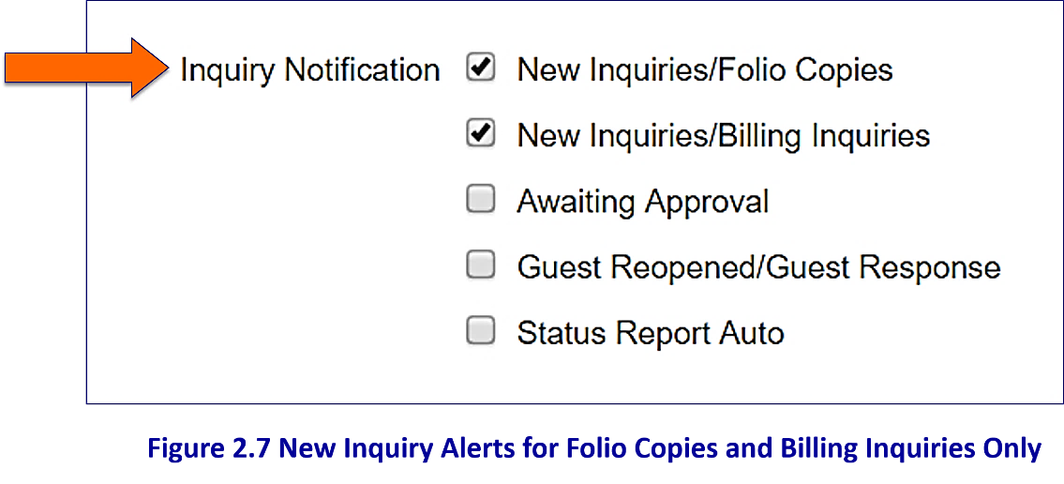

**Figure 2.8 New Inquiry Alerts for Folio Copies and Billing Inquiries Only**

|  |
| --- |
| **NOTE** |
| You may also choose not to activate either (or both) of the new inquiry notification options. If so, a processor will need to go into the system throughout the day to see if a new inquiry has been received. To select/deselect this option simply click in the appropriate cell. |

The next two “**Notification Options**" shown below happen less frequently and **should be selected** (especially the "**Awaiting Approvals**" option for the accounting team and the Administrator):

* **Awaiting Approvals**
* **Guest Reopened / Guest Response**

Choosing to receive "**Awaiting Approval**" and "**Guest Reopened**" notifications will ensure all inquiries are fully processed. You can always change any of your selections later.

The final notification option is “**Status Report Auto.**” Selecting this option will prompt the system to send the registrant a “**Status Report**” monthly (or "**on demand**" as desired). This option should be selected for all "**Notification Recipients**" set up in the Authority portion of the page as shown in Figure 2.9. It's also useful for the Administrator and any other Managers with Direct Reports using the system.

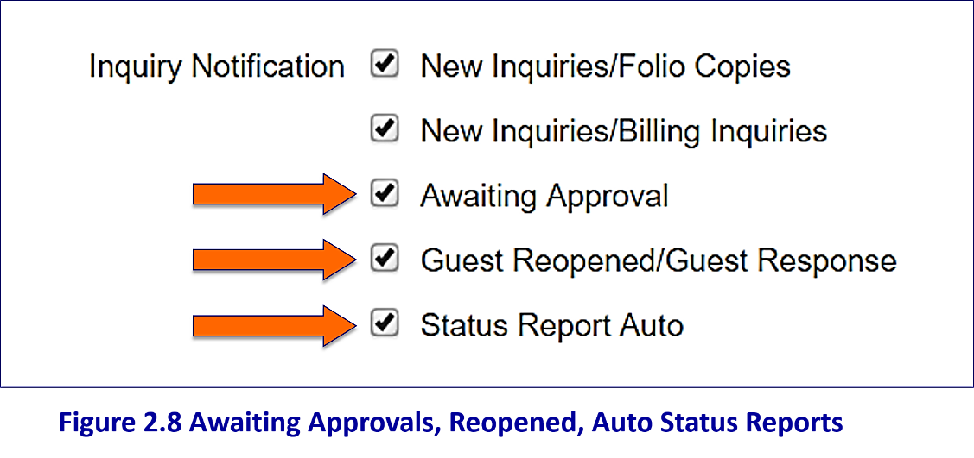

**Figure 2.9 Awaiting Approvals, Reopened, Auto Status Reports**

|  |
| --- |
| **NOTE** |
| **The Status Report** is intended to inform managers of the number of guest inquiries you’re receiving and processing each week. It is a Report generated in the Reports tab of the system. (Best Practice is to select Regional Managers, General Managers, AGM’s, Directors of Finance, and ADOF’s to receive Status Reports – if they are not the Administrator already). |

The final step in the registration process is to select the property/properties to which the registrant will be assigned as shown in Figure 2.10. Simply click in the appropriate box to select the property as shown. Click “**Add**” when finished to save the registration.

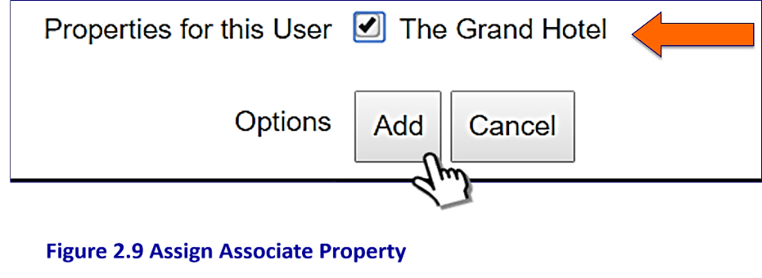

**Figure 2.10 Assign Associate Property**

|  |
| --- |
| **NOTE** |
| The associate will automatically appear in the Properties tab as an associate of the property selected in this step. |

When the new associate has been added, the system will return to the registration Main Page. The registrant's name will appear at the bottom of the “**Associate**” list as shown in Figure 2.11.

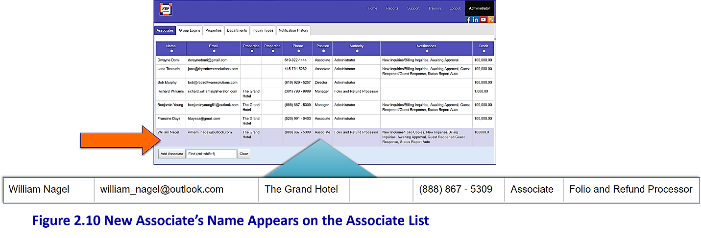

**Figure 2.11 New Associate’s Name Appears on the Associate List**

|  |
| --- |
| **NOTE** |
| Property names are pre-designed during the system installation. To modify or add properties, contact support or your property I.T. Systems Manager. |

Re-Sorting the list of Associates on the Main Page

You may re-sort the list of associates on the Main Page of the Associates tab by clicking the arrow next to the column heading “**Name"** this will sort the list of usersalphabetically (by first name). Clicking the arrow, a second time will re-sort the list in descending alphabetical order. You may also re-sort the list of registrants by any of the column headings simply by clicking on the arrows next to the column headings.

Re-Setting Passwords, Editing Registrations, and Deleting Associates

To **reset a password** or delete an associate from the system, go to the "**Administrator Tab**" (on the Main Menu) and select the "**Associates tab**." This will display a list of registrants as shown in Figure 2.12 below:

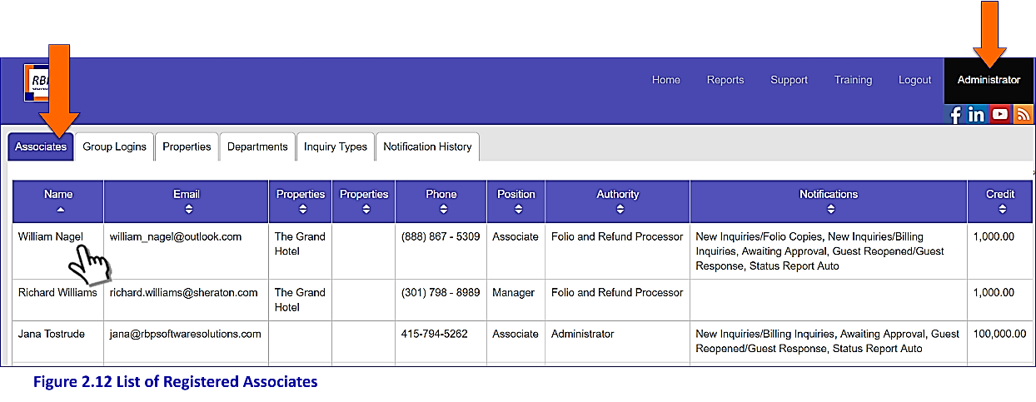

**Figure 2.12 List of Registered Associates**

"**Click**" to "**select**" the associate's name from the list of registered users to reveal the associate's profile as shown in Figure 2.13:

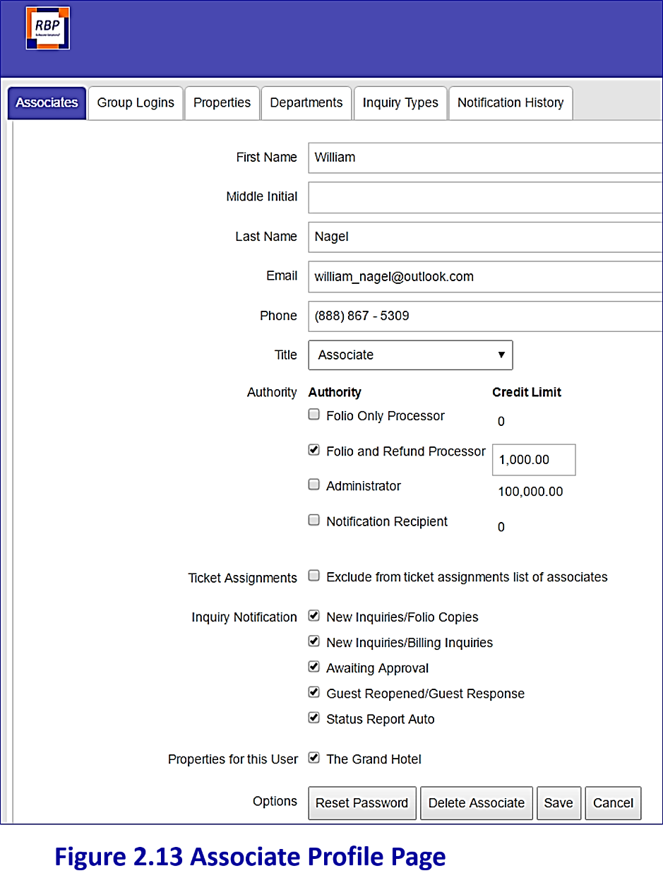

**Figure 2.13 Associate Profile Set-Up Page**

Scroll to the bottom of the associate's profile page; select the appropriate option: Reset Password, Delete the Associate, or Save Changes as shown in Figure 2.14:

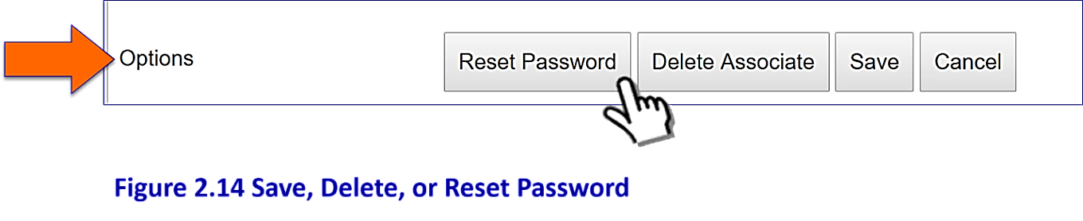

Figure 2.14 Save, Reset Password, or Delete Associate

|  |
| --- |
| **NOTE** |
| To edit an associate registration, simply select the associate name, make the appropriate changes, and select "**Save**" from the options shown. |

Group Logins Tab: Creating a Group Login

Group Logins

The “**Group Login**” tab allows you to set up **one login** for an entire department rather than setting up each person individually. This is especially helpful if setting up the Front Desk or Guest Services to process folios.

To set up a Group Login select the “**Add Group Logins**” tab from the Administrator menu as shown in Figure 3.1:

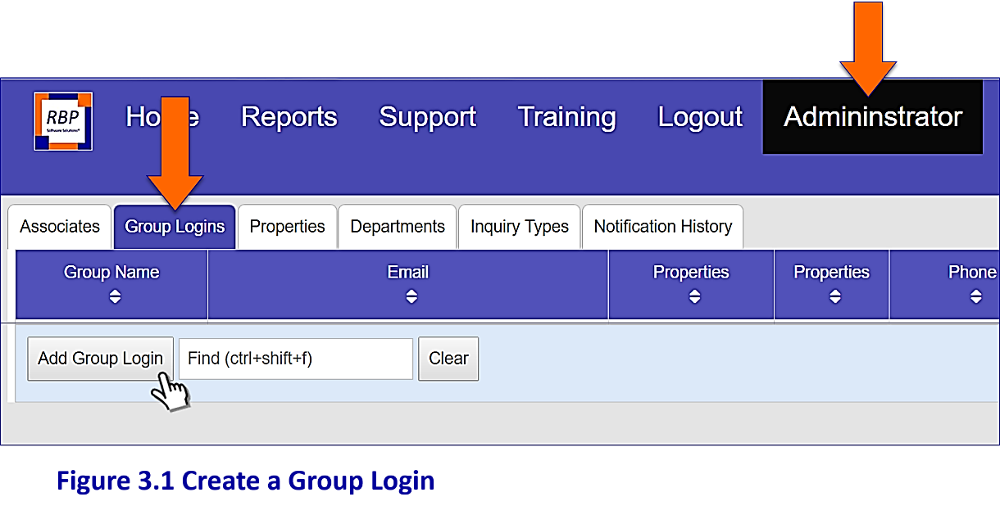

**Figure 3.1 Add a Group Login**

Enter the “**Group Name**” “**Email”** and **“Phone Number”** in the appropriate cells as shown in Figure 3.2. The “**Email**” box should be completed with the Department email address and the “**Phone**” box with the Department phone number.

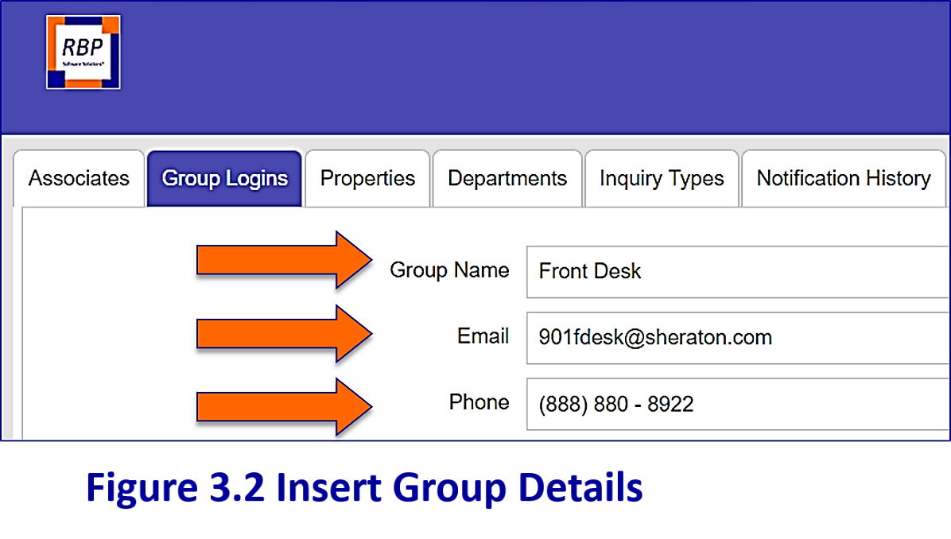

**Figure 3.2 Insert Group Details**

The dropdown box next to “**Max Logins**” sets up the maximum number of users that may **log onto the system at the same time** (**not** the maximum number of users per group login)**.**

|  |
| --- |
| **NOTE** |
| When setting up a Group, you may set up **one** "**Group Login**" for a department of 20 people (or more); with the Max Logins button you will simply set the maximum number of those associates that may sign onto the system at the same time. This is a security measure. The maximum number is five. |

Select the maximum number from the drop-down menu as shown in Figure 3.3:



**Figure 3.3 Set Maximum Users Logging in at the Same Time**

The “**Authority**” box works exactly as it does in the “**Associates**” tab:

* If you’re registering the Front Desk or Guest Services to process tickets as a group, you should choose “**Folio Only Processor**” if they will process folios only. However, if they will process credits as well, select the “**Folio and Refund Processor**” box.

To assign an “**Authority**” simply select the appropriate cell as shown in Figure 3.4. (Don’t worry about the “**Credit Limits**” for now – we discuss this topic later in this module).

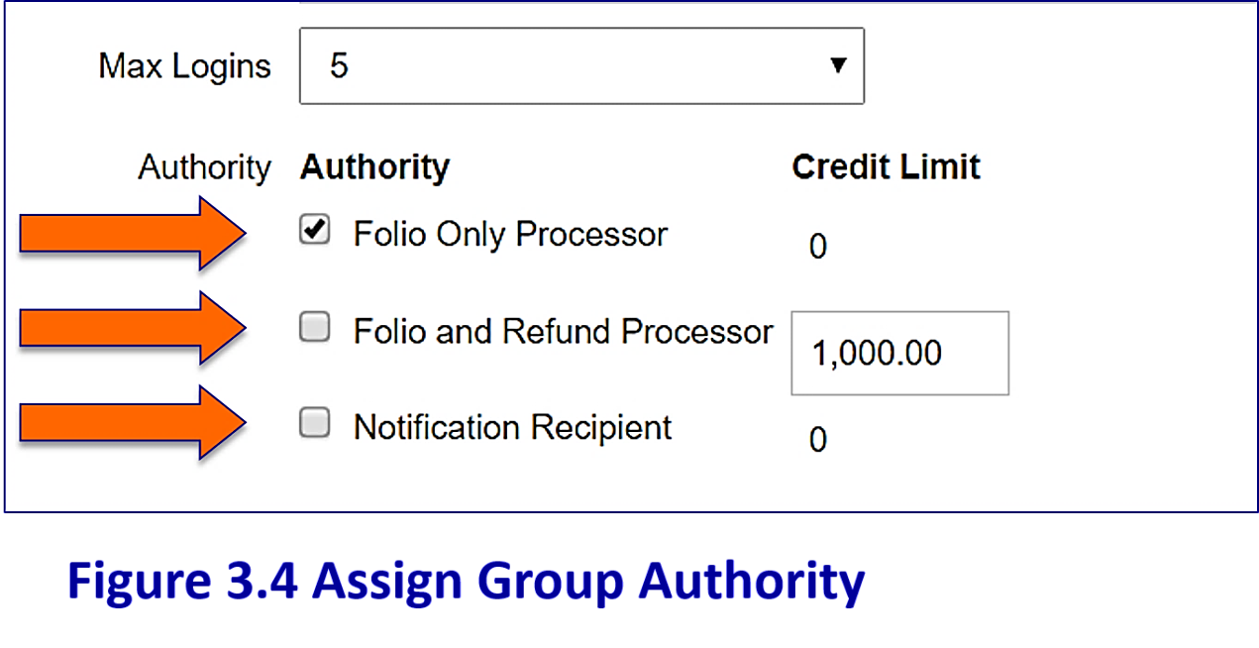

**Figure 3.4 Assign Group Authority**

The “**Inquiry Notification**” boxes are exactly as they were for setting up associates in the prior section. Group Inquiry Notification options are shown in Figure 3.5 below:

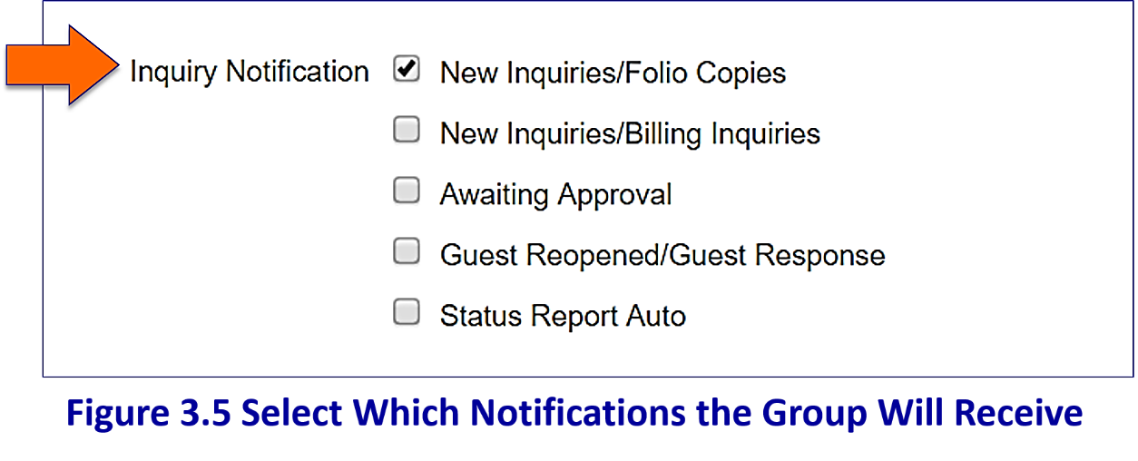

**Figure 3.5 Select Which Notifications the Group Will Receive**

|  |
| --- |
| **NOTE** |
| A big advantage of the system is the ability to set up a group (i.e. the front desk) to process folios. To set them up to receive notifications for folios only, select the Inquiry Notification "**New Inquiries: Folios Only**". |

When setting up notification options, keep in mind that each notification email contains both a copy of and a link to the new inquiry: this will allow the processor (I.e. the Front Desk associate) to simply "**click the link**" at the bottom of the inquiry notification email and go **directly to the new inquiry for processing**.

|  |
| --- |
| **NOTE** |
| The group login solution also means that the group will receive **only one notification for each new folio request.** The notification will be sent to the group email address entered on the registration page. |

**Best Practice for All Groups** is to select the **“New Inquiries”** boxes. While separating the New Inquiry notifications between "**folios only**" and "**billing issues**" does a lot to cut down on the number of emails received, the **“New Inquiries”** boxes still generate the greatest number of notification emails.

|  |
| --- |
| **NOTE** |
| If you choose not to select either (or both) of the **“New Inquiries”** boxes, please ensure that an Associate is assigned as the Group's *RBP Guest Inquiries* Representative. This Associate must then be responsible for checking the system throughout the day for new inquiries. |

The final step in setting up a Group Login is to select the property/properties to which the “**Group”** belongs by clicking in the appropriate cell (shown in Figure 3.6 below). Click the “**Add**” button in the lower portion of the screen to save your input and return to the main menu.

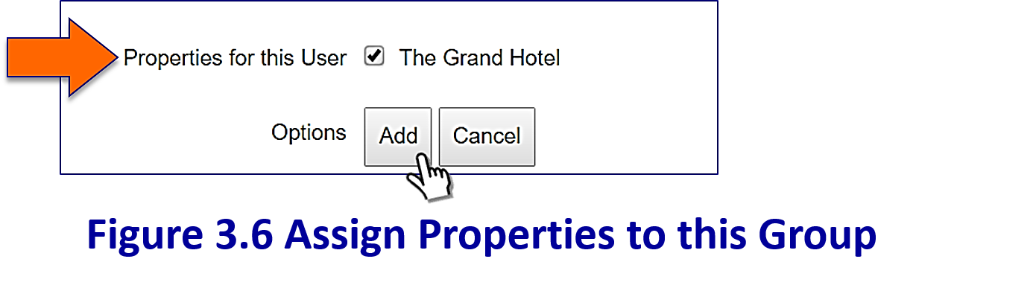

**Figure 3.6 Assign Properties to this Group**

The main screen will display a list of “**Groups**” that have been set up. As you build additional groups, there may be multiple pages – navigate between pages by clicking the page number or "**next page**" as shown in Figure 3.7:

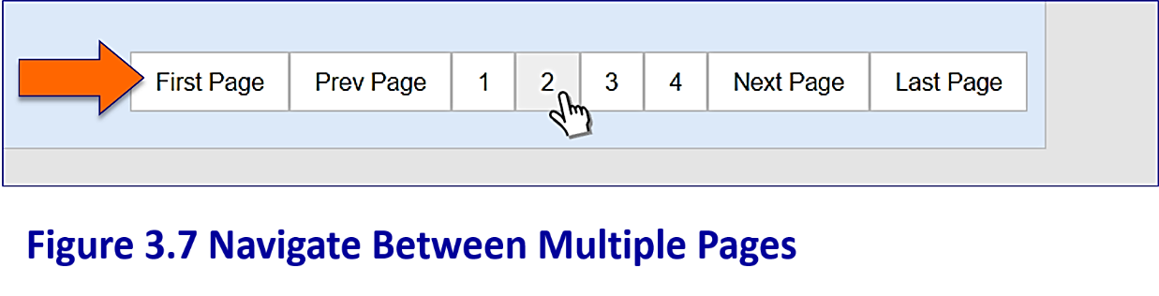

**Figure 3.7 Navigate Between Multiple Pages**

|  |
| --- |
| **NOTE** |
| Should you wish to leave the Group Login screen and return to the main menu at any time without saving your changes simply select the “**Cancel**” button. |

|  |
| --- |
| **NOTE** |
| The group will automatically appear in the Properties Tab under “**Property Associates”** and listed as an associate or user of the property assigned. |

Departments Tab: Selecting/Deselecting Departments

The next two steps in the setup process allow you to customize two data fields: “**Departments**” and “**Inquiry Types**”. Departments and Inquiry Types are used in sorting and processing inquiries and should be set up to represent the various inquiries your property receives.

Customizing Departments

We pre-loaded your system with a set of common industry "**Departments**” as shown in Figure 4.1 below:

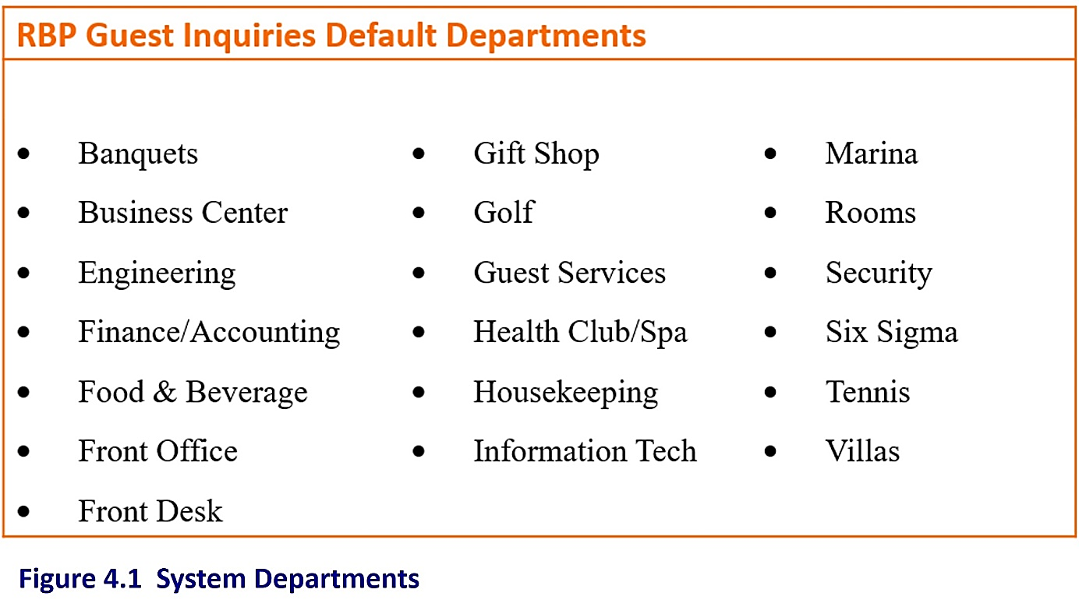

Figure 4.1 System Departments

You should customize this list to represent your property's Accounting Departments and the kinds of inquiries you receive. For instance, if your property does not have a golf course or a tennis court, you may choose to remove "**Golf**" and "**Tennis**" from your departments list (we'll show you how to remove departments below). Additionally, although your property may have an "**Engineering Department**" if you never receive an inquiry related to the engineering department you may want to remove "**Engineering**" from your departments list as well. Don't worry, if you remove a department from the list and want to "**re-add**" it later, you can.

|  |
| --- |
| **NOTE** |
| “**Departments**” are used to give detail to your billing inquiries when creating reports. If you set up your Departments List to match your property’s Accounting Departments, you will be able to generate a “**Chargeback Report**” to match your “**General Ledger**”. This can be very useful when trying to locate reporting errors. |

To customize your Departments, select the “**Departments**” tab from the “**Administrator**” menu as shown in Figure 4.2 below:

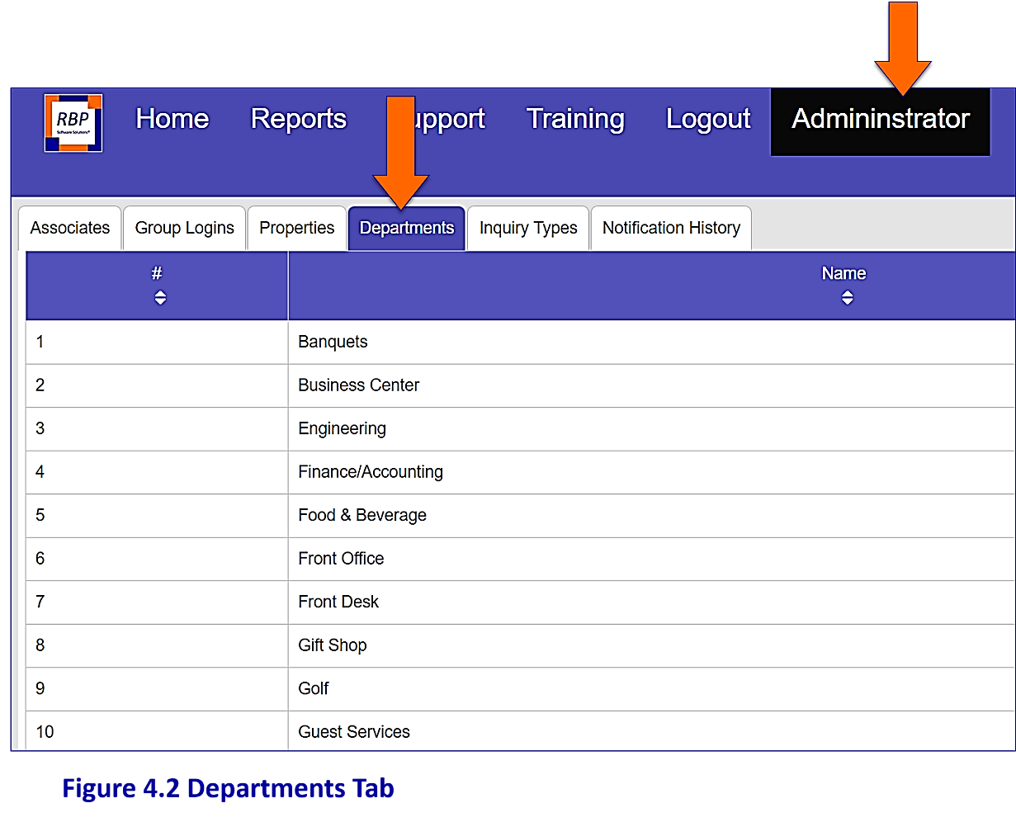

**Figure 4.2 Departments Tab**

There are multiple pages in the “**Departments**” list; select the page number or “**Next Page**” in the lower right of the screen to navigate between pages as shown in Figure 4.3.

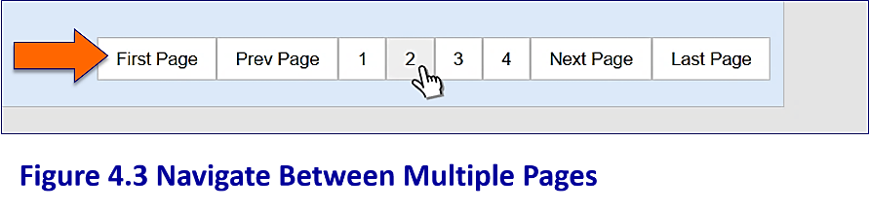

Figure 4.3 Navigate Between Pages

As mentioned earlier, we enabled all departments to appear in your department list during setup. To remove a specific “Department” from your departments list simply click on the appropriate Department name as shown in Figure 4.4:

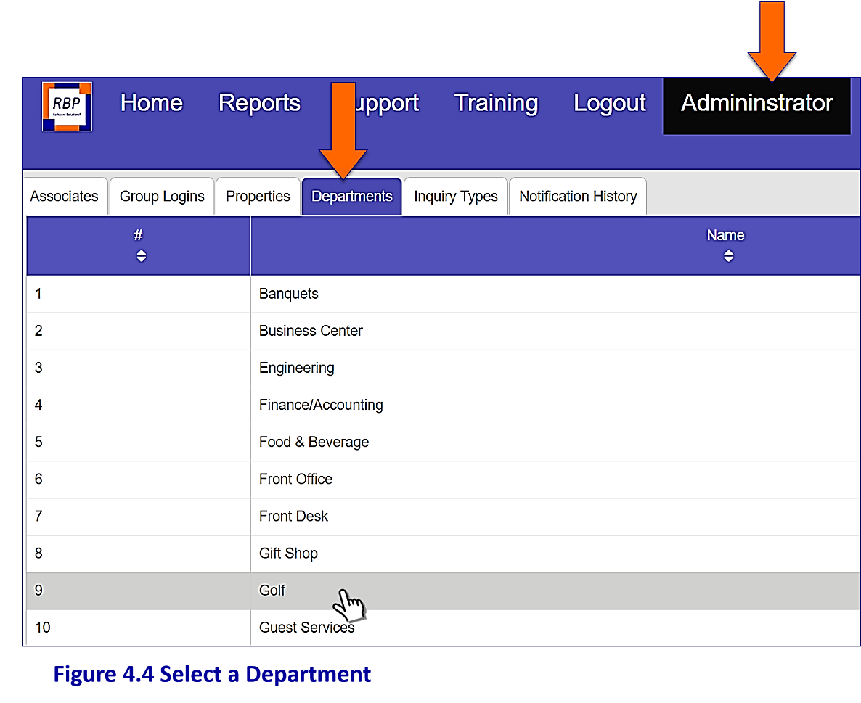

Figure 4.4 Select a Department

Next, click the **"Department Enabled"** box next to **"For this Property"** as shown in Figure 4.5. This will remove the check mark from the cell and prevent the Department from appearing in your Department list.

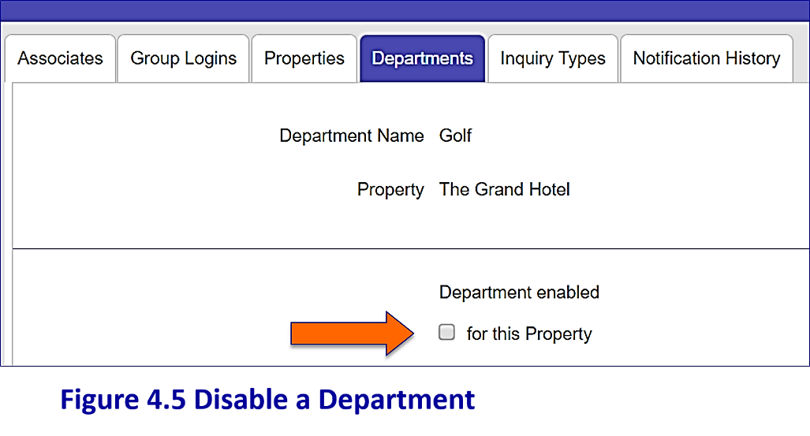

Figure 4.5 Disable a Department

|  |
| --- |
| **NOTE** |
| For now, leave the "**Send all Notifications**" “**To This Property**” box blank as shown in Figure 4.6. Also, don't worry about selecting Department Contacts. We'll discuss that later under Sending Internal Comments to Departments. |

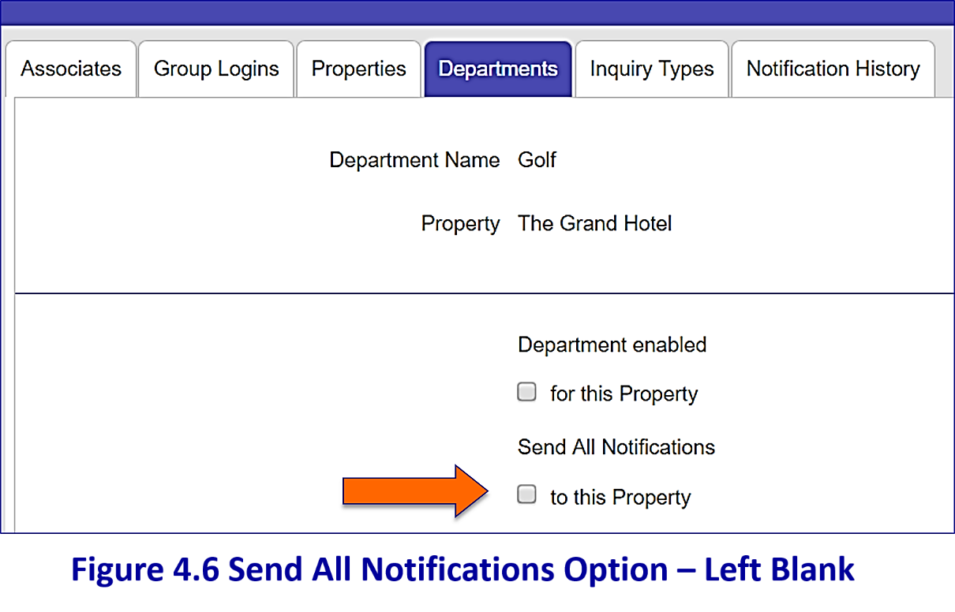

**Figure 4.6 Send All Notifications Option – Left Blank**

**Department Contacts are discussed later in this module. Skip this optional feature for now.**

To save your changes and return to the Departments Main Page, simply click the “**Save**” button at the bottom of the screen as shown in Figure 4.7:

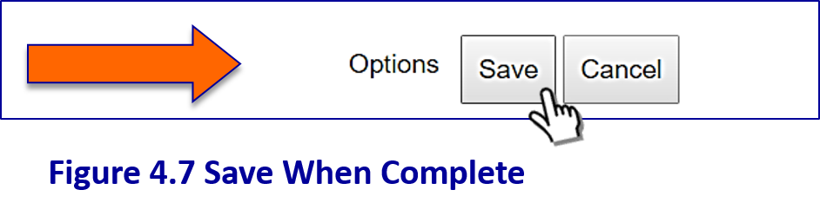

**Figure 4.7 Save When Complete**

Even though you "**Disabled**" a Department (***Golf*** in this example) from your Departments list, that Department name will still appear on the Departments Main Page. It will, however, disappear from the Departments "**Dropdown Menu**" on the Active Tickets processing page as shown below (golf, tennis and engineering have been removed from the dropdown menu)

in Figure 4.8:

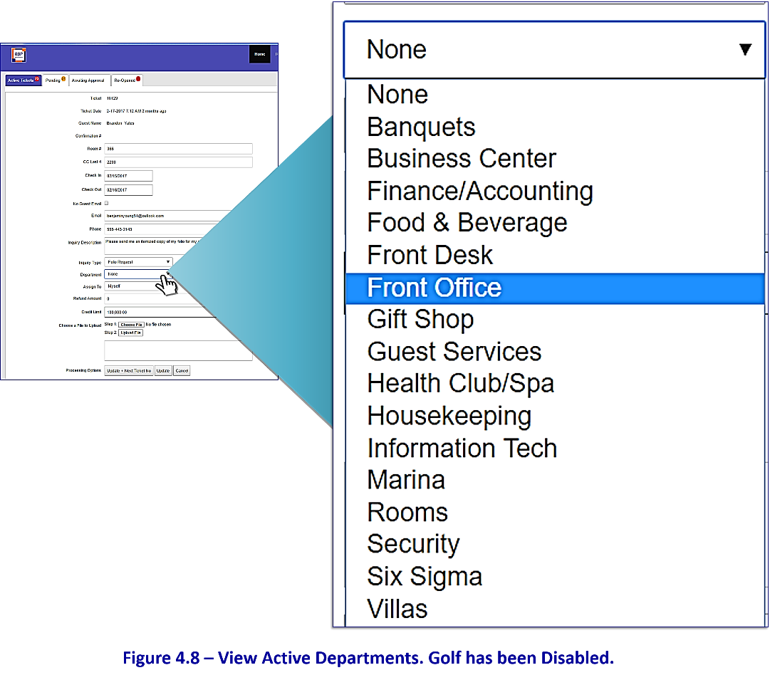

Figure 4.8 – View Active Departments on the Inquiry Processing Page.

In this example, Golf has been Disabled.

|  |
| --- |
| **NOTE** |
| As mentioned, "**Disabling**" a Department from your property department list does not remove it from the list of possible departments on the Departments Main Page. This will allow you to "**re-enable**" it at a later time if desired. |

Inquiry-Types Tab

Customizing Inquiry Types

We have also loaded your system with a set of default “**Inquiry Types**”. You may customize your property's Inquiry Types by "**enabling/disabling**" them just as you did with your Departments.

“**Inquiry Types**” represent the kinds of inquiries you receive (i.e. folio request, double charge, etc.); they are used to sort and give further detail to your inquiries when creating reports. The full list of available Inquiry Types is shown in Figure 5.1 below:

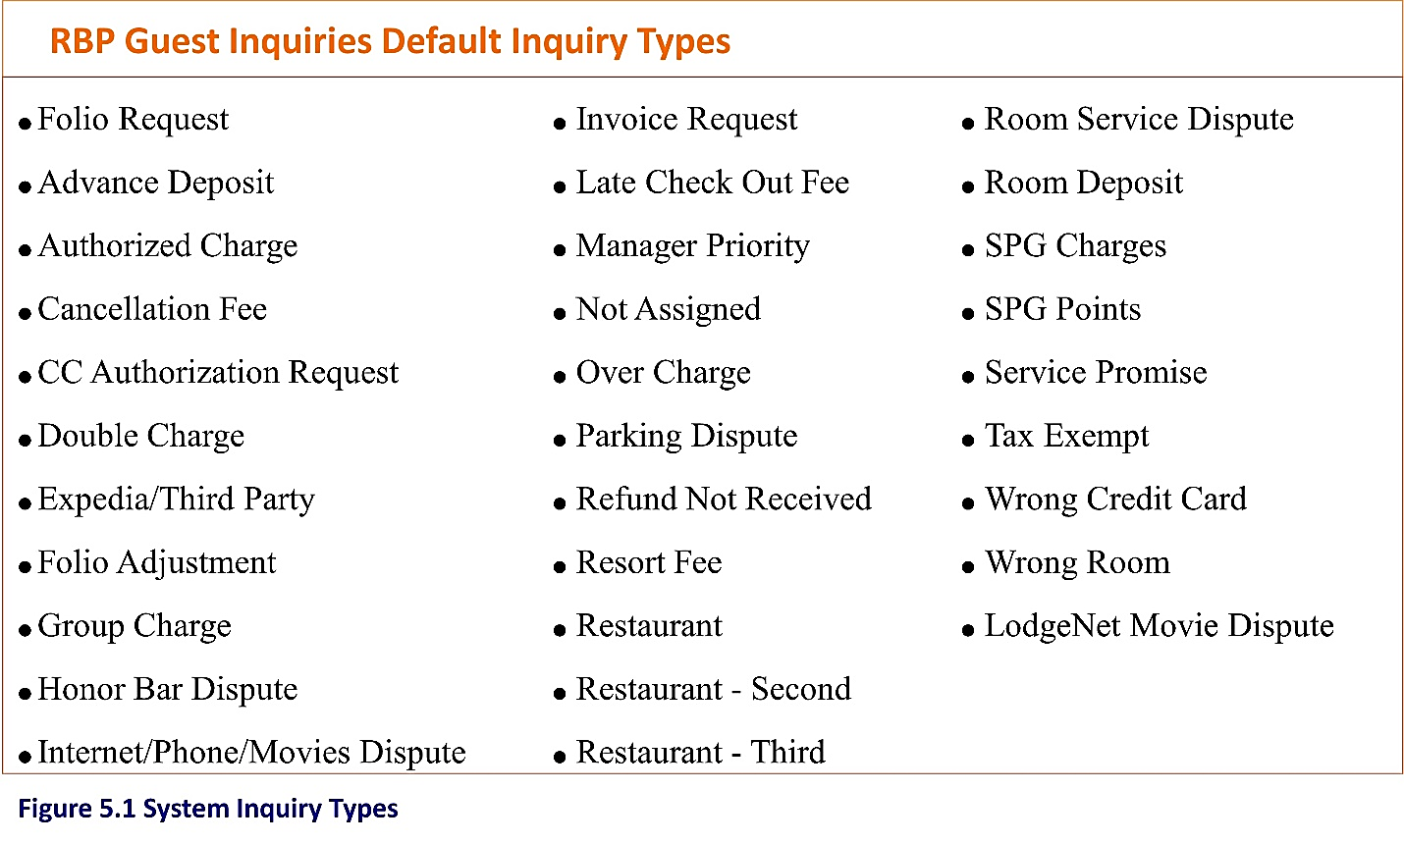

Figure 5.1 System Inquiry Types

You should try to keep your list of Inquiry Types as small as possible to allow for quicker processing. We have found that a list of ten to fourteen inquiry types is sufficient for many properties.

To customize your inquiry types, select the “**Inquiry Types**” tab from the “**Administrator**” menu as shown in Figure 5.2 below:

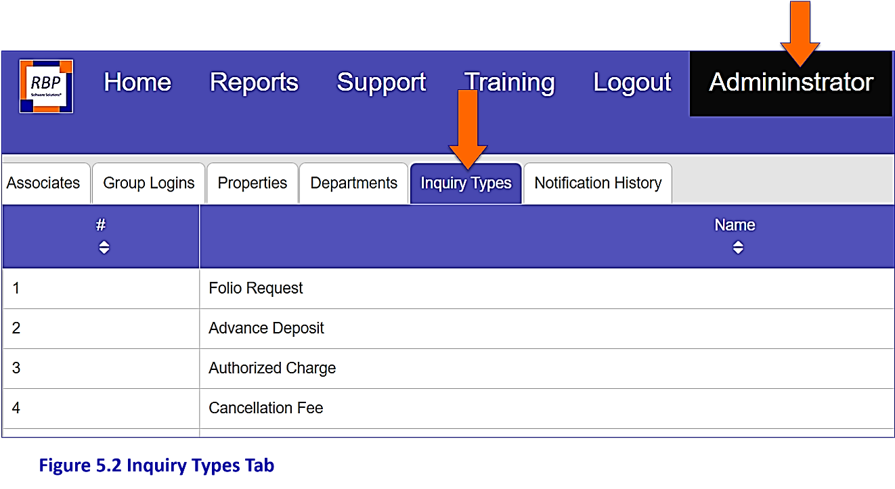

**Figure 5.2 Inquiry Types Tab**

There are multiple pages to the list. Select the appropriate page number or “**next page**” in the lower right of the screen to view the full list as shown in Figure 5.3:

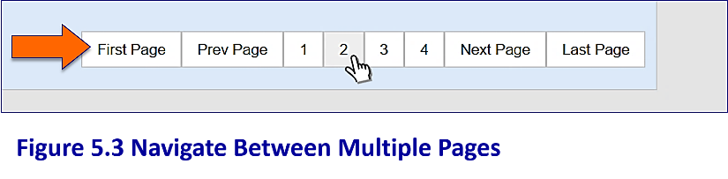

Figure 5.3 Navigate Between Pages

As with departments, all “Inquiry Types” have been "**enabled for your property**" in the implementation process and will appear in your initial list of inquiry types.

To remove an Inquiry Type from this list simply click on the appropriate Inquiry Type name as shown in Figure 5.4:

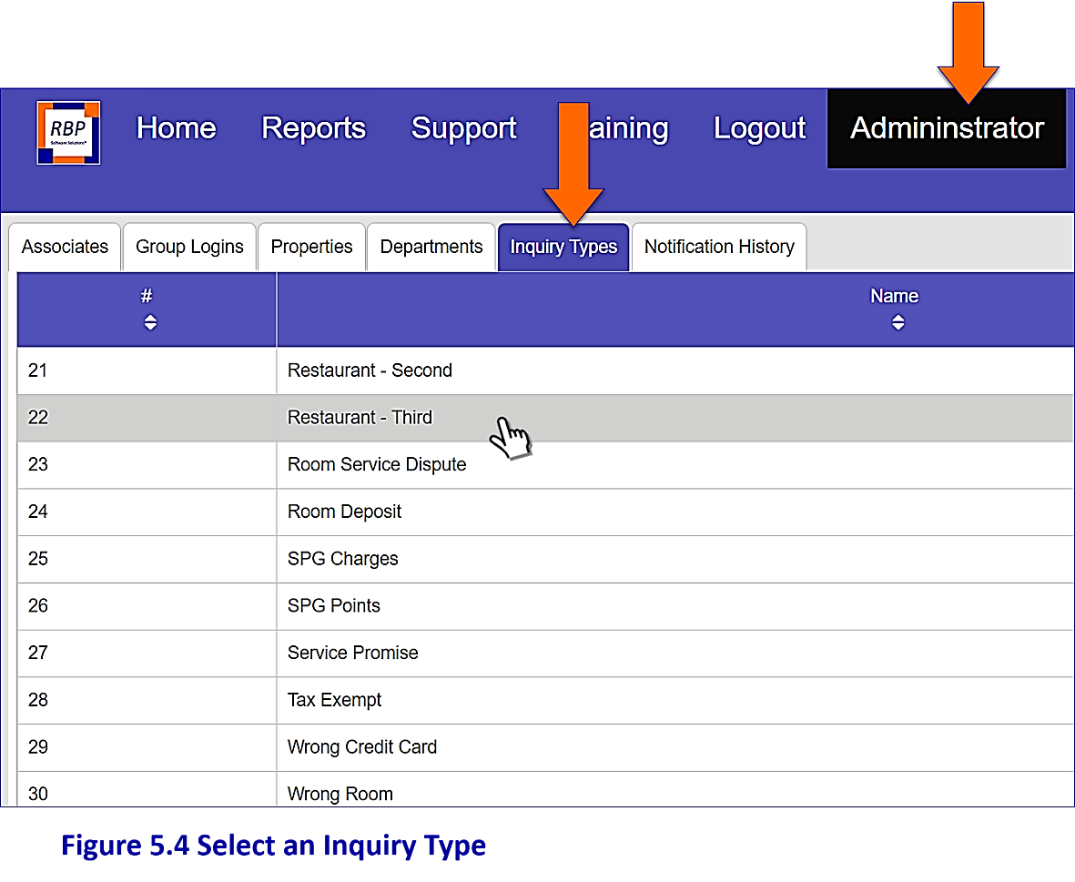

**Figure 5.4 Select an Inquiry Type**

Click in the "**Inquiry Type Enabled**" “**for this Property**” cell to remove the check mark and "**Disable**" the inquiry type for your property as shown in Figure 5.5:

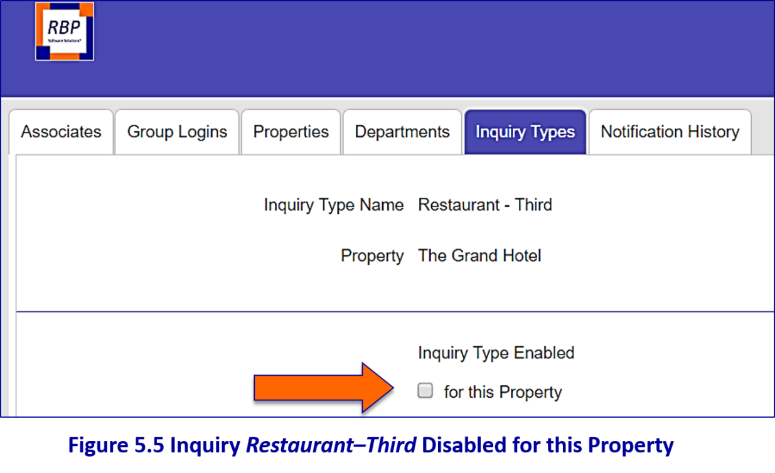

Figure 5.5 Example Inquiry Type: *Restaurant–Third* Disabled for this Property

To save your change and return to the Inquiry Types Main Page simply click the “**Save**” button as shown in Figure 5.6:

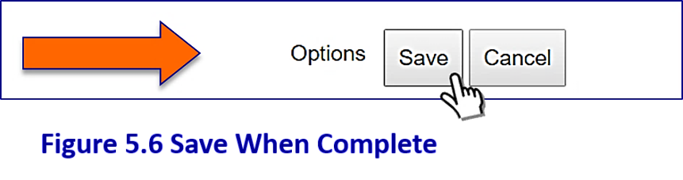

Figure 5.6 Save When Complete

|  |
| --- |
| **NOTE** |
| The "**de-selected/disabled**" Inquiry Type will still appear on the Main Inquiry Types page to allow you to "**re-add**" it later if you wish. Your de-selected Inquiry Type will disappear from the dropdown list of available Inquiry Types on the Active Tickets processing page as shown in Figure 5.7: |

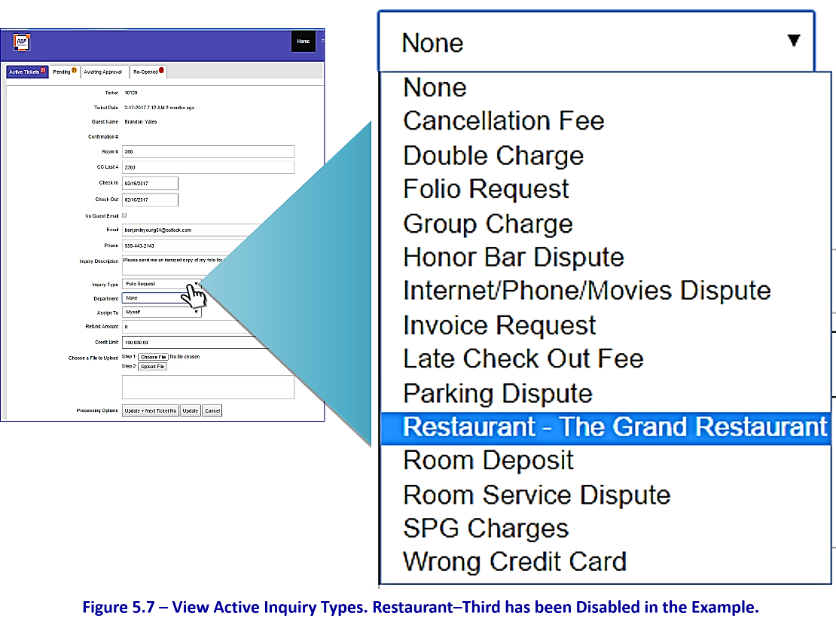

Figure 5.7 – View Active Inquiry Types on the Inquiry Processing Page.

In this example, Restaurant-Third has been Disabled.

Customizing Inquiry Types with an Optional Sub-Description

We have included a feature that allows you to tailor Inquiry Type names to your property if desired. This is done in the "**optional sub-description**" cell as described below. This is a helpful step when there are more than one restaurant and bar choices at a single property.

In the example that follows, we're going to add the restaurant name "***The Grand Restaurant***" to the Inquiry Type "***Restaurant***".

To begin, select the Inquiry Type "**Restaurant**" from the Inquiry Type list as shown in Figure 5.8 below:

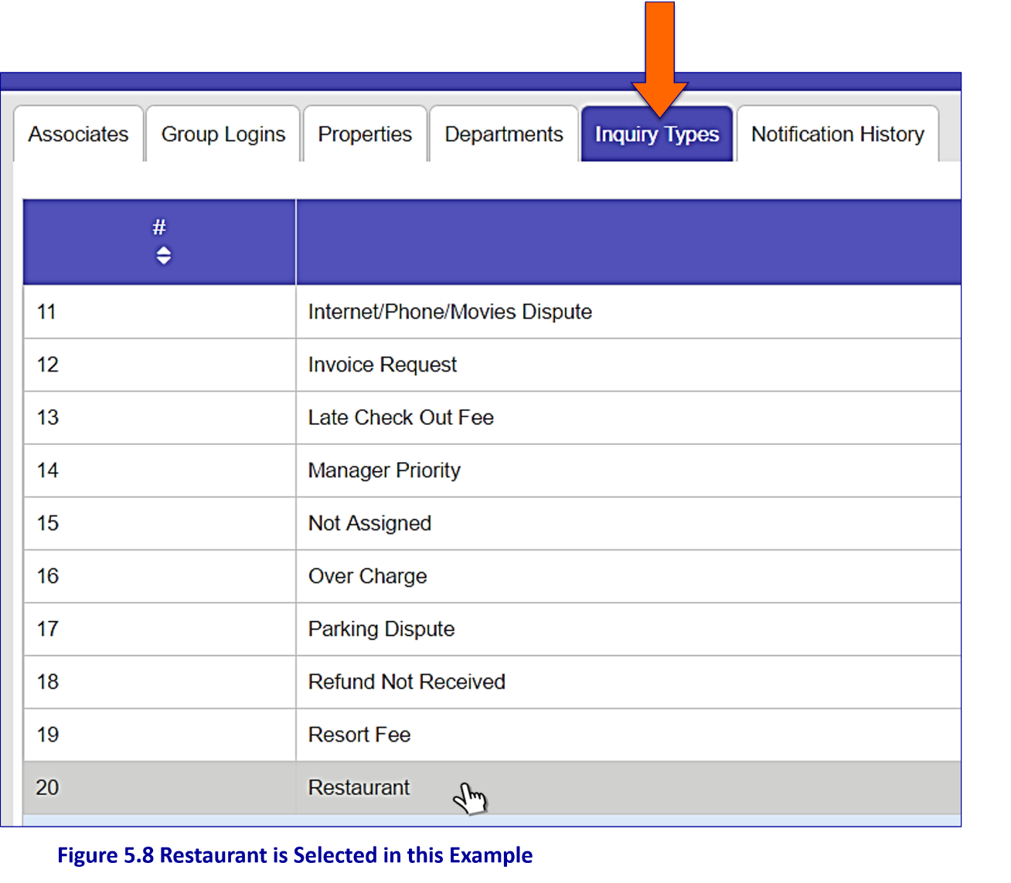

Figure 5.8 Restaurant is Selected in this Example

To customize an Inquiry Type name, you must "**enable the Inquiry Type**" by clicking the "**for this property**" box as shown in Figure 5.9:

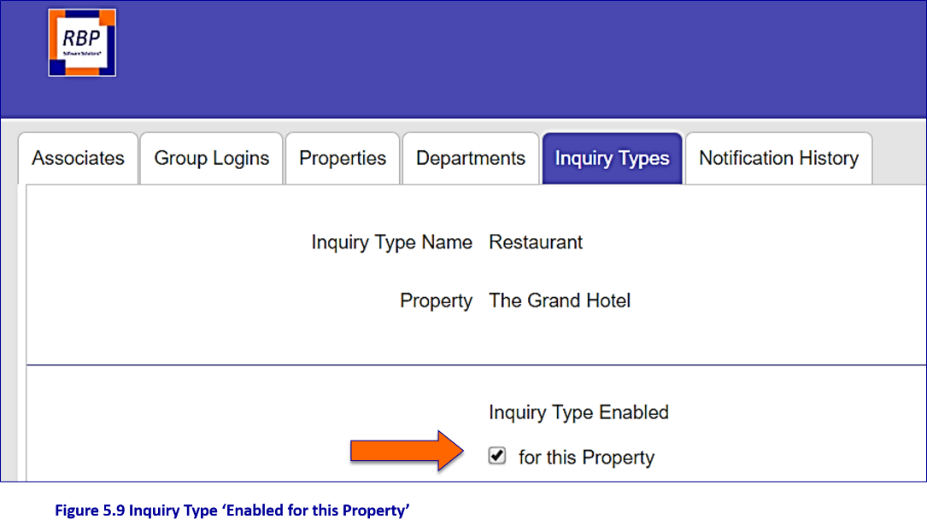

Figure 5.9 Inquiry Type ‘Enabled for this Property’

In the cell "**Optional Sub-Description**" add the words "**The Grand Restaurant**" (i.e. your restaurant name) as shown in Figure 5.10.

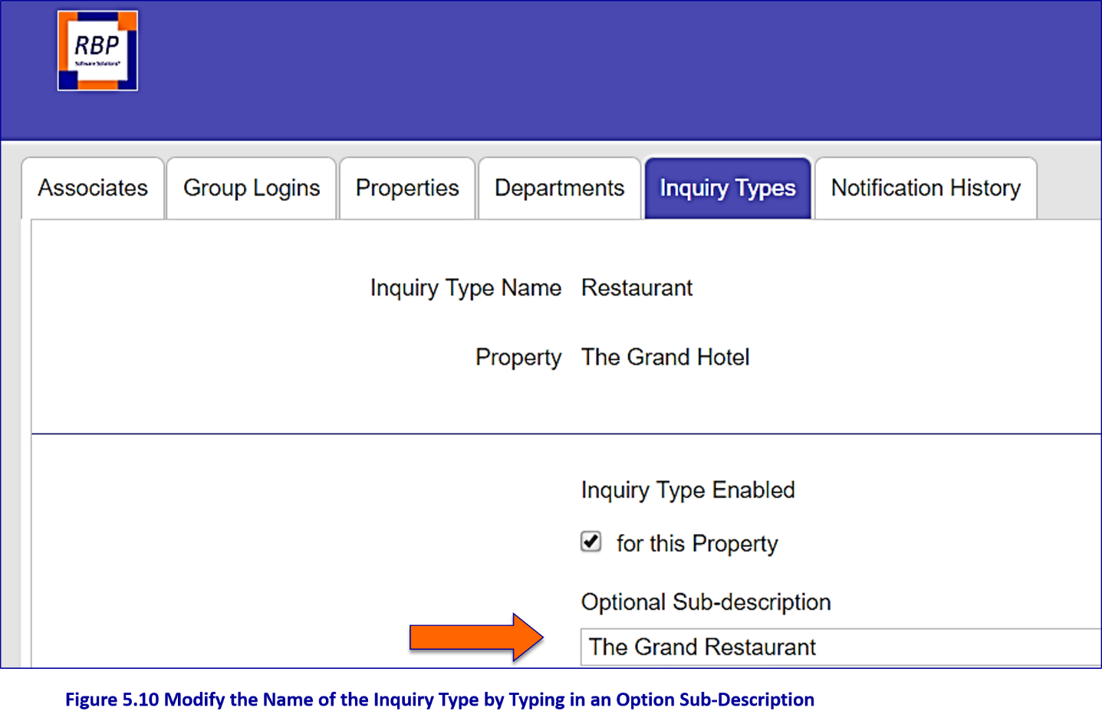

**Figure 5.10 Modify the Name of the Inquiry Type by Typing in an Option Sub-Description**

When finished click the “**Save**” button as shown in figure 5.11 at the bottom of the screen to save your change and return to the Inquiry Type Main Page.

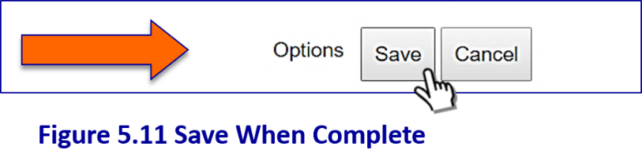

Figure 5.11 Save When Complete

|  |
| --- |
| **NOTE** |
| The change will not appear on the Inquiry Types Main Page; it will appear on the dropdown menu of Inquiry Types on the Active Tickets processing page as shown below in Figure 5.12. |

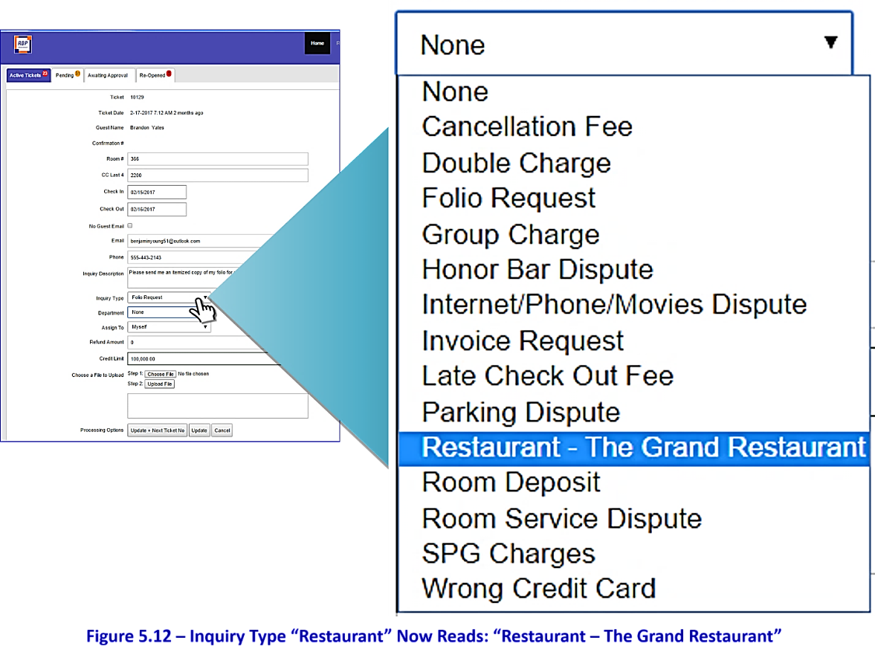

**Figure 5.12 – Active Inquiry Types. In this Example, “Restaurant”**

**Now Reads: “Restaurant – The Grand Restaurant”**

Properties Tab

Customizing Guest Emails and Editing Property Information

The “**Properties**” tab allows you to edit property information and customize guest emails. Properties are pre-loaded during installation. To display properties available to you select the “**Properties**” tab from the “**Administrator**” menu as shown in Figure 6.1:

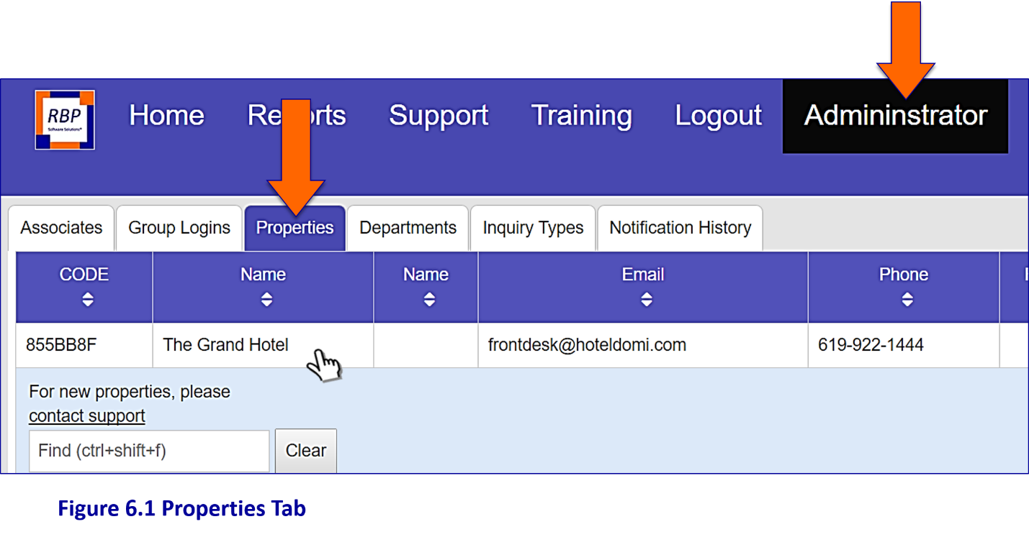

Figure 6.1 The Properties Tab

To view and update property information, click on the property name and you’ll be taken to the property information page shown in Figure 6.2.

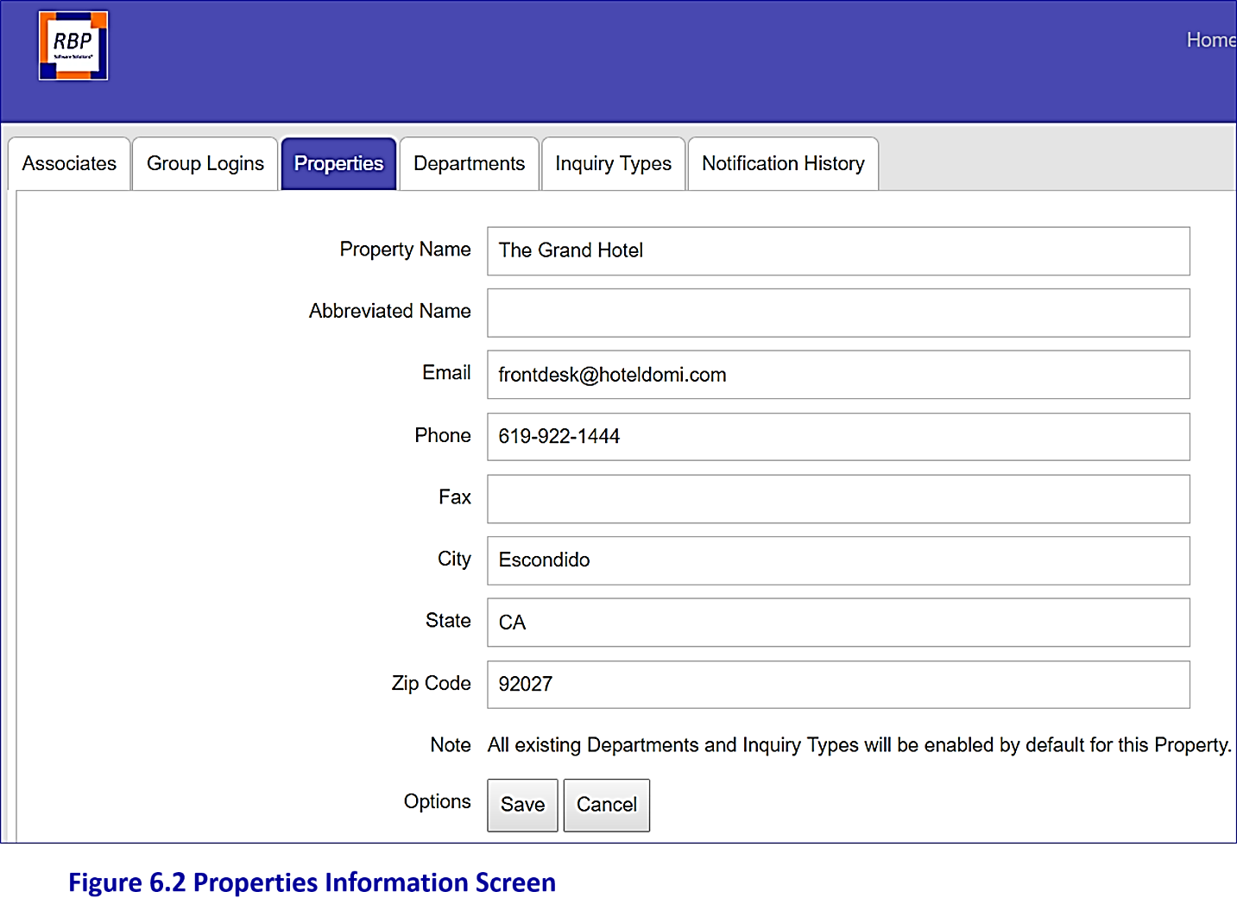

Figure 6.2 Property Information Screen

Verify the property contact information in the top section of the page to ensure accuracy, edit if necessary and hit the “**Save**” button to save any changes. Selecting the "C**ancel**" button at any time will return you to the Properties Main Page where the list of properties available to you are displayed.

The middle portion of the **Property Screen** contains information on your guest-facing pages as shown in Figure 6.3.

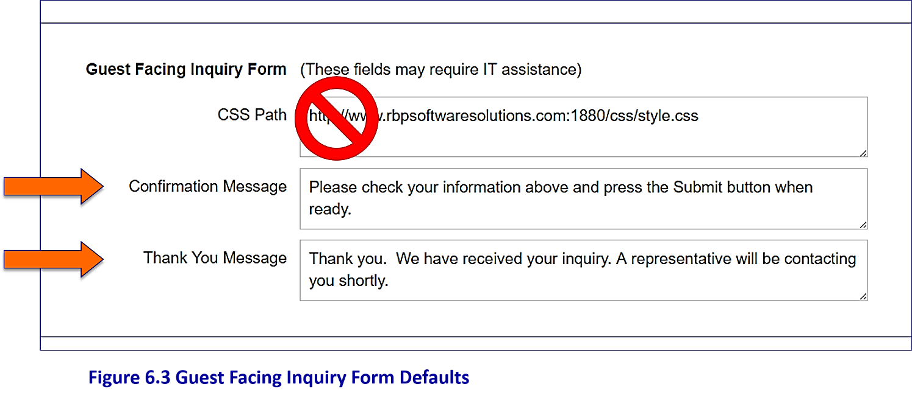

**Figure 6.3 Guest Facing Inquiry Form Defaults**

|  |
| --- |
| **NOTE** |
| **Default messages are pre-programmed.**  **These messages can be modified during the installation of RBP Guest Inquiries.**  **DO NOT MODIFY THE CSS PATH.**  **Contact support should you have any questions regarding this information.** |

Guest Emails

The lower section of Property Information page is used to customize guest-facing emails. Click the dropdown arrow in the “**Guest Email Defaults**” box to display the available guest emails as shown in Figure 6.4:

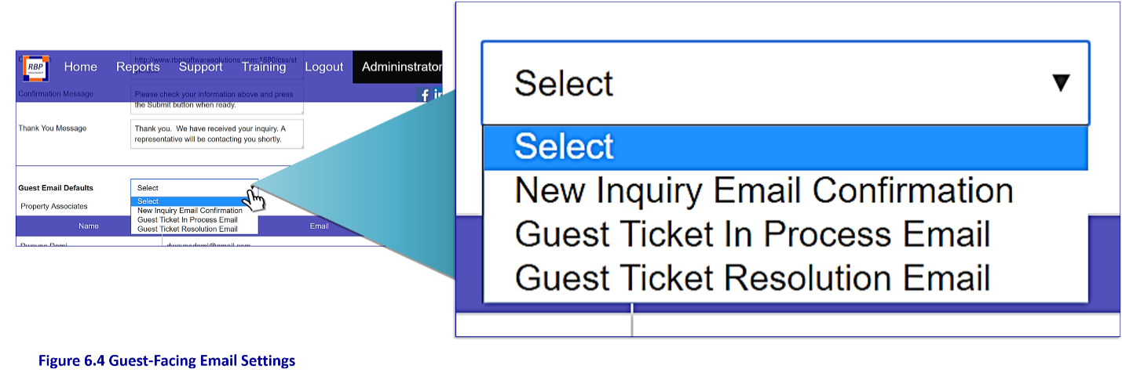

**Figure 6.4 Guest-Facing Email Settings**

These standardized guest emails may be customized if desired. To view each of the available options simply click on the appropriate email name to reveal the message contents as shown in the three figures below.

You may edit/customize the "**Message Body**" and "**Message Subject**" on any of the emails: to make changes simply enter the new text in the appropriate boxes and hit the “**Save**” button at the bottom of the page.

**1.** “**New Inquiry Email Confirmation**”

This automatic email is sent to the guest when the inquiry is received by RBP Guest Inquiries. In Figure 6.5, the *From Email Address, Subject,* and *Message Body* have been customized.

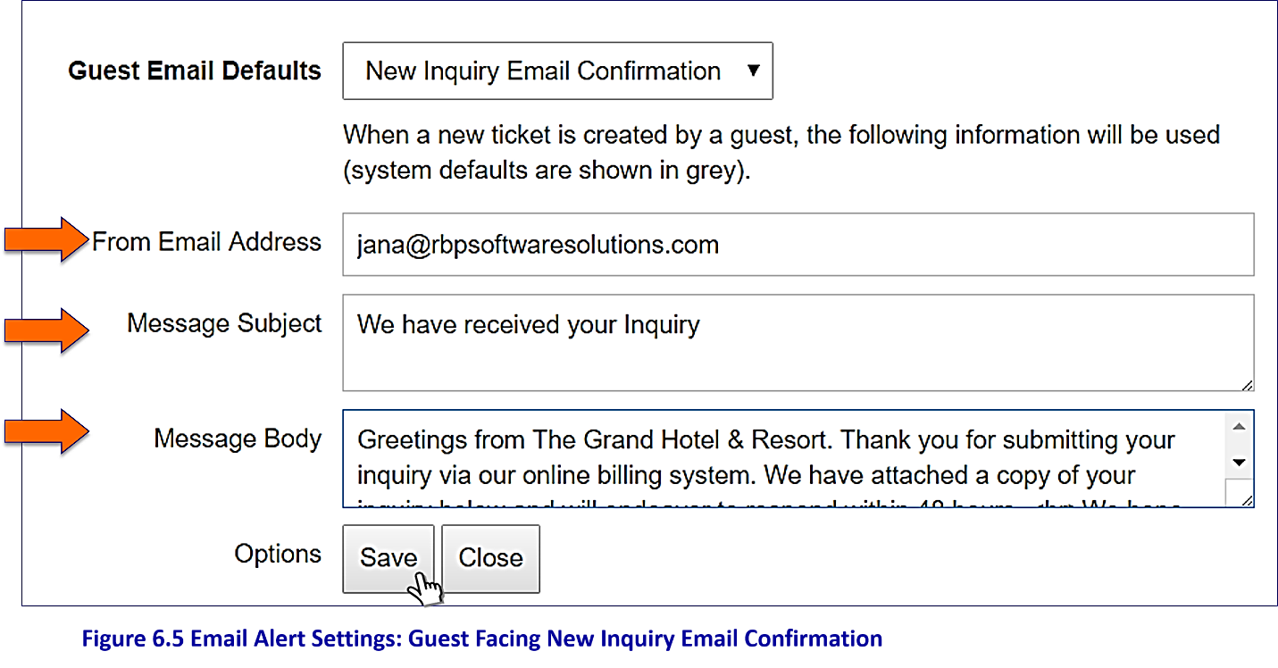

**Figure 6.5 Email Alert Settings: Guest Facing New Inquiry Email Confirmation**

The email that the guest will receive based on the settings above is shown below in Figure 6.6.

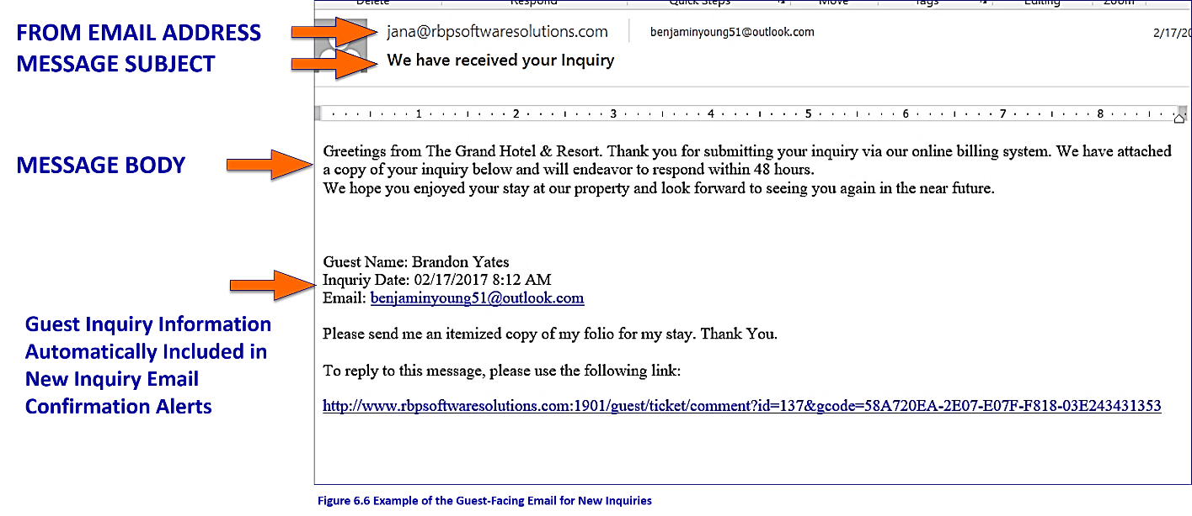

**Figure 6.6 Example of the Guest-Facing Email for New Inquiries**

**2**. “**Guest Ticket In-Process Email**”

This email is sent to the guest only if the processor chooses to send an External Comment to the guest **but does not close the inquiry.**  In Figure 6.7, the *From Email Address, Subject,* and *Message Body* have been customized.

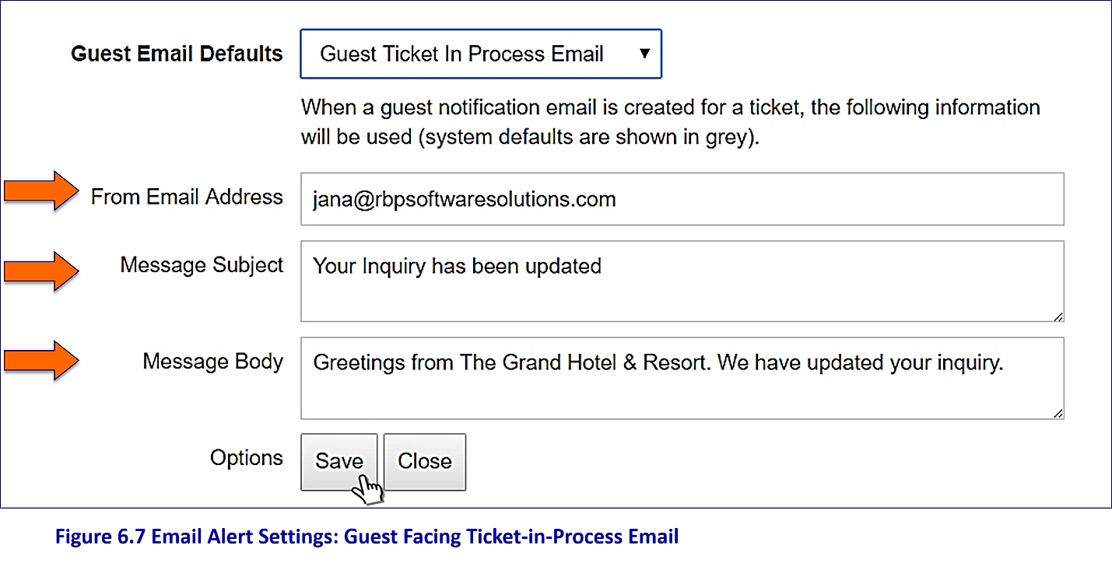

**Figure 6.7 Email Alert Settings: Guest Facing Ticket-in-Process Email**

The email that the guest will receive based on the settings above is shown below in Figure 6.8.

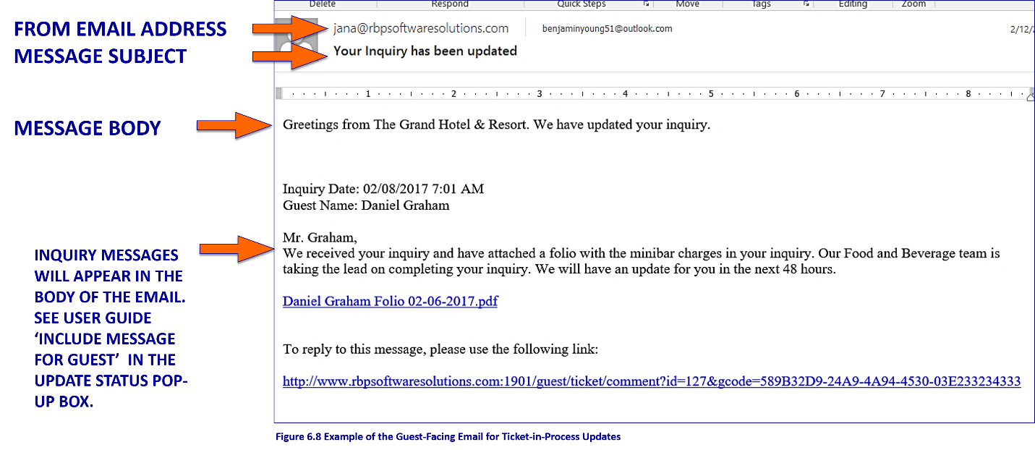

**Figure 6.8 Example of the Guest-Facing Email for Ticket-in-Process Updates**

**3.** “**Guest Ticket Resolution Email**”

This email is sent to the guest when the processor **closes** the inquiry and selects the “**Close and Send Resolution Email**” button. In Figure 6.9, the *From Email Address, Subject,* and *Message Body* have been customized.

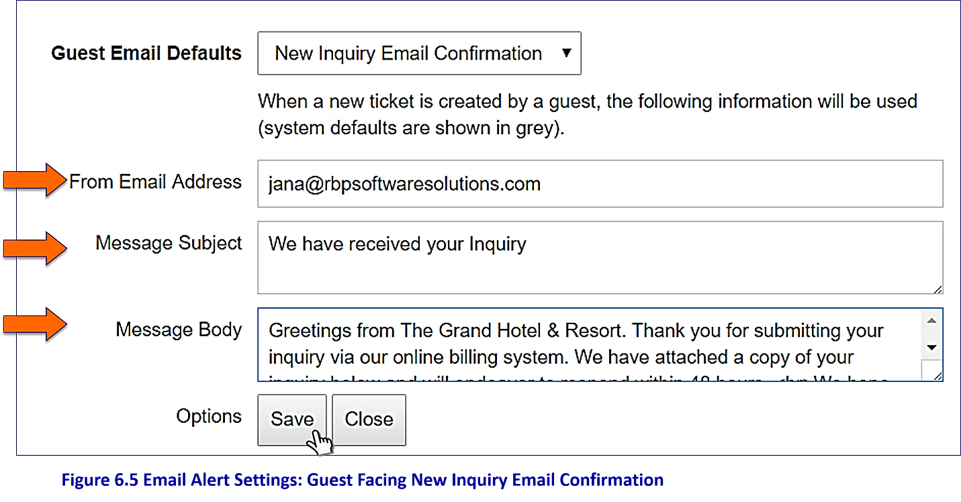

**Figure 6.9 Email Alert Settings: Guest Facing Ticket Resolution Email**

The email that the guest will receive based on the settings above is shown below in Figure 6.10.

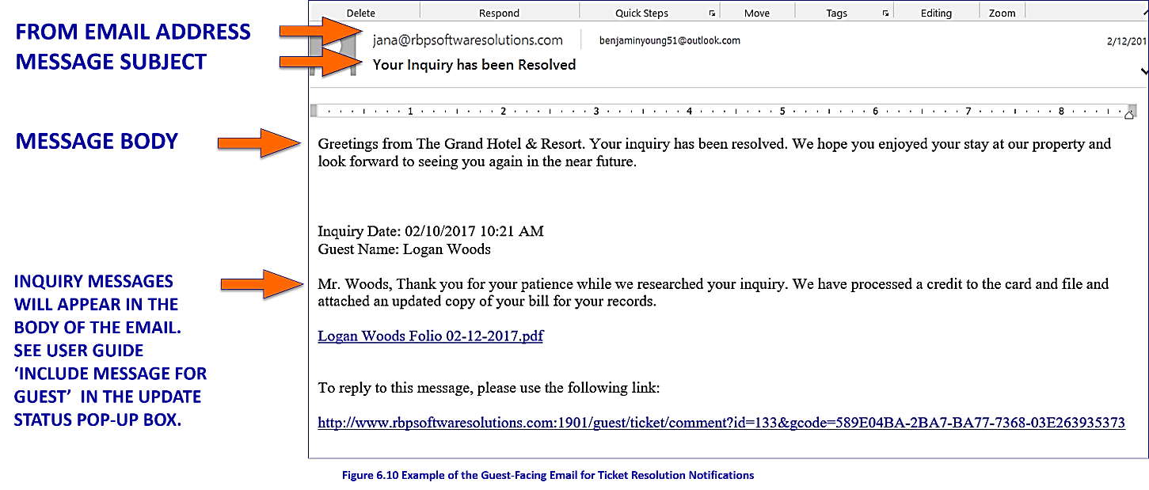

**Figure 6.10 Example of the Guest-Facing Email for Ticket Resolution Notifications**

The lower portion of the **Property Tab** displays associates assigned to your property as shown in Figure 6.11:

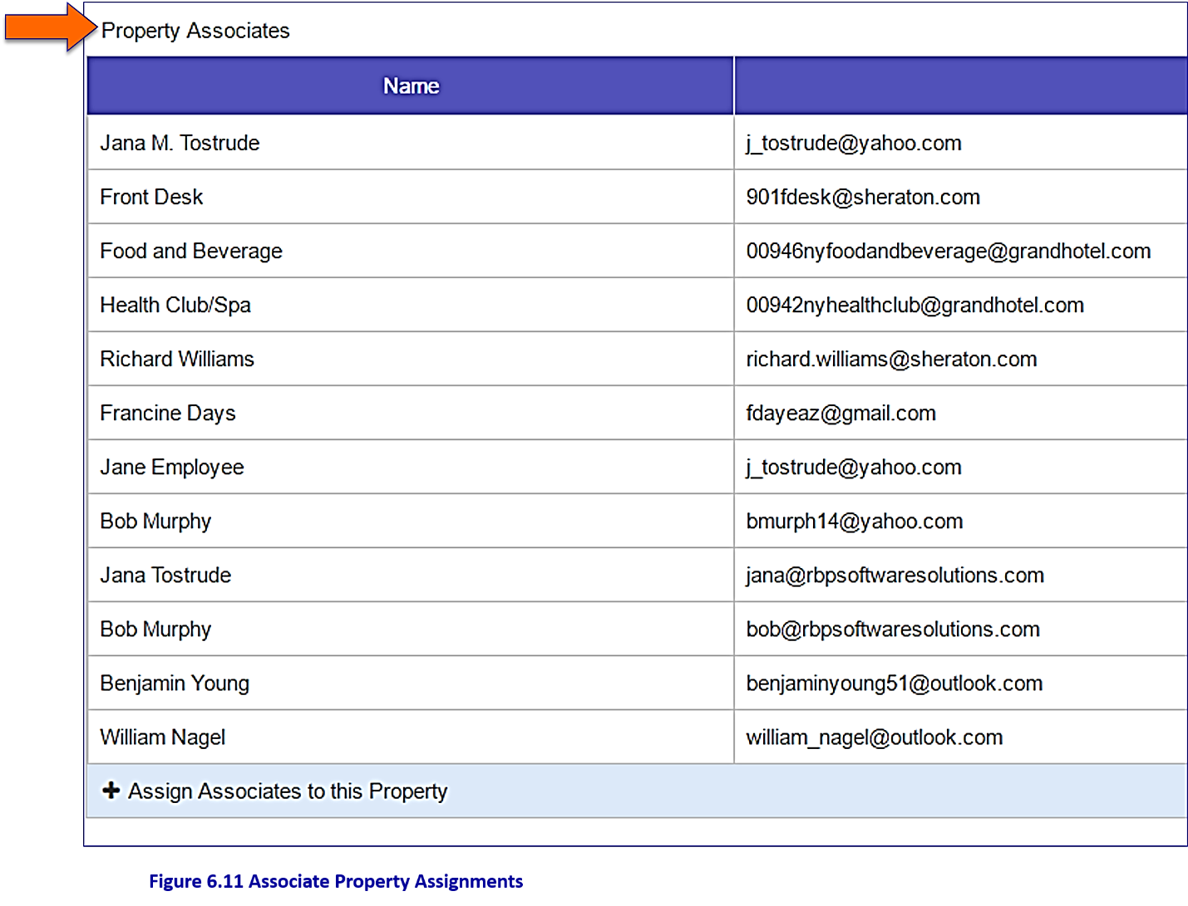

**Figure 6.11 Associate Property Assignments**

|  |
| --- |
| **NOTE** |
| Associates and Groups assigned to this property will appear in the **Property Associates** list. Additional associates can be added manually by selecting the Assign Associates to this Property option. |

Verifying Inquiries by Sending "Internal Emails" to Department Contacts **(optional)**

We have added an optional feature that allows a processor to verify an inquiry by sending an email to the affected department without leaving the system (i.e. Sending an Internal Email to a Department). This would be especially helpful in verifying refund requests.

|  |
| --- |
| EXAMPLE 1: |
| Assume you were processing an inquiry requesting a refund for a massage the guest did not receive. In this case the processor might want to check with the Spa to ensure that the guest did not have the massage. Setting up Internal Communication for the Department would allow the processor to send an email to the Spa without leaving the system. |

Setting up Internal Communications for Department Groups

Setting up **Internal Communications** for **Department Groups** is a 3-step process:

**STEP 1:** Set up the Department as a Group in the Group Logins tab. This will load the department's contact information into the system.

**STEP 2:** Go to the Departments tab and display the appropriate department information.

**STEP 3**: In the Department Contact section, select the Department Contact Name.

|  |
| --- |
| EXAMPLE 2: |
| In this example we're going to set up the Health Club/Spa to receive an internal communication/email from the inquiry processor. Don't worry, it's a simple process as shown in Figures 7.1 and 7.2. |

As mentioned, the **first step** is to **add the Health Club/Spa contact information to the system** in the **Group Login tab** of the **Administrator** menu. Click the "**Add Group Login**" button in the lower left corner of the screen as shown below in Figure 7.1:

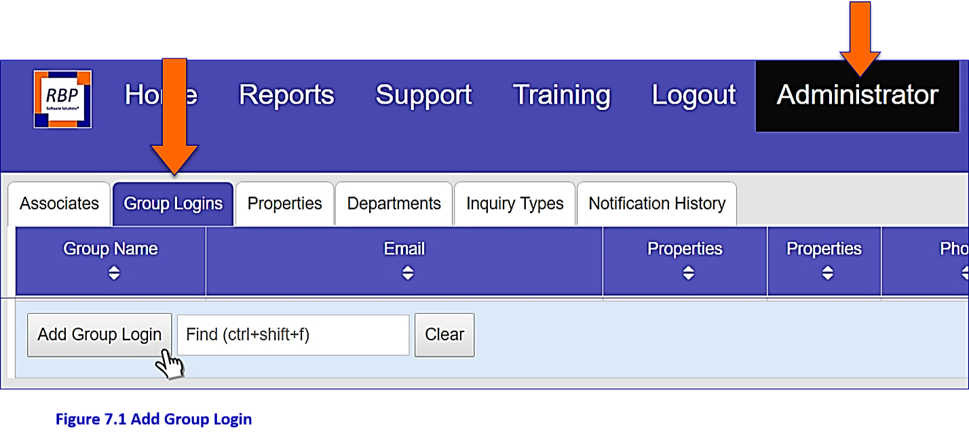

Figure 7.1 Add Group Login

**STEP 1-A:** Enter the Health Club/Spa contact information into the appropriate cells in the Group Information Screen as shown below in Figure 7.2.

**STEP 1-B:** Since this Department will not process inquiries (but will only receive messages from the processor), select "**Notification Only Recipient**" in the "**Authority**" section of the Group Information Screen and leave the Inquiry Notifications boxes empty as shown in Figure 7.2.

**STEP 1-C:** Add the “**Properties for this user**” by selecting the property box at the bottom of the Group Information Screen as shown in Figure 7.2:

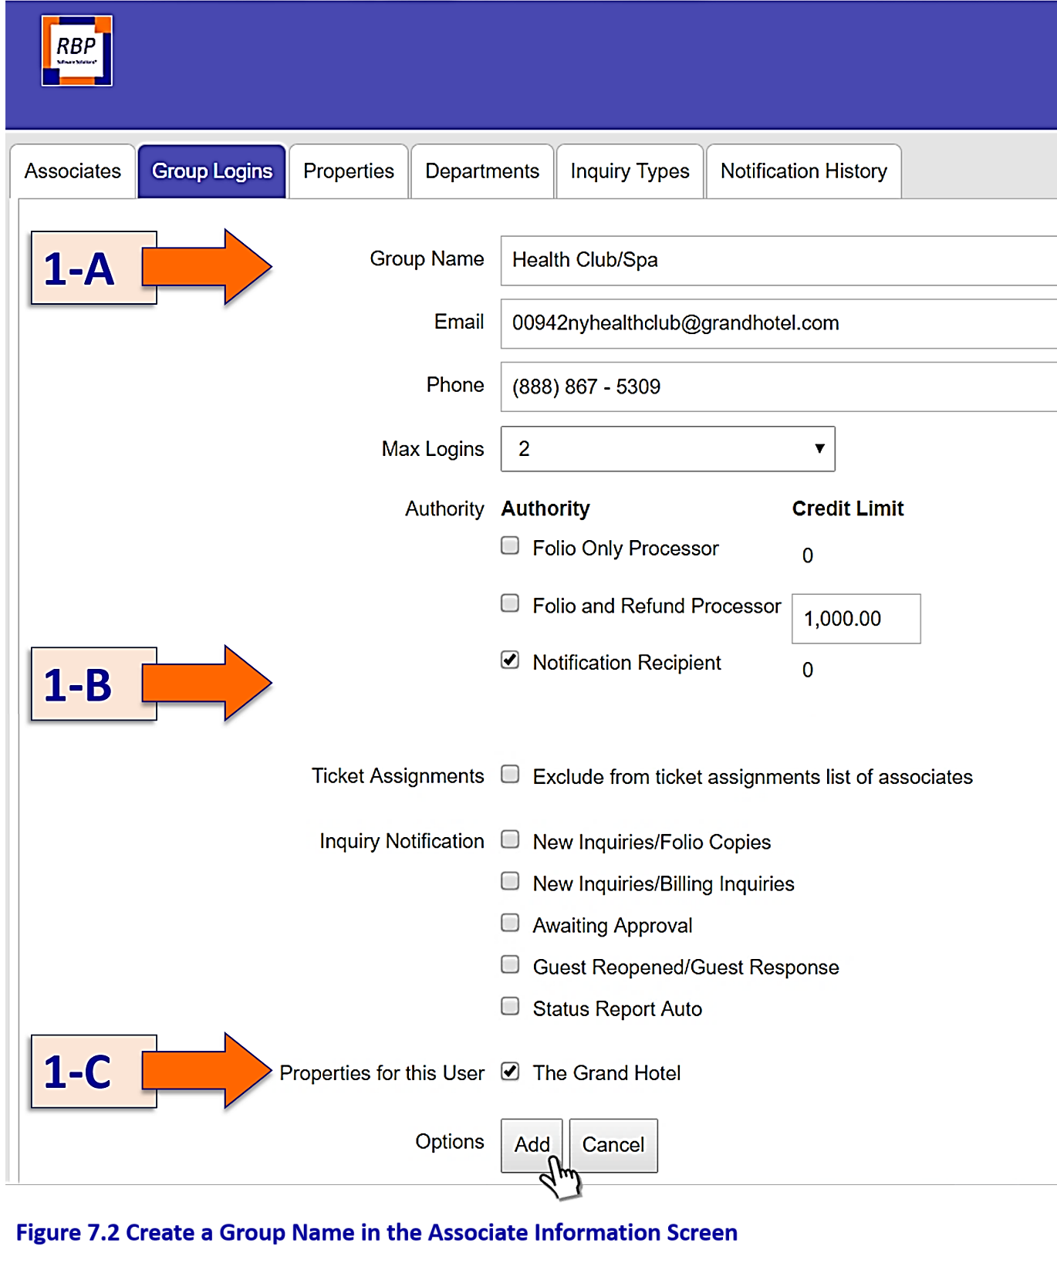

**Figure 7.2 Create a Group Name in the Associate Information Screen**

When finished, click the “**Add”** button to save the contact information for the Department.

Now, for **STEP 2**, go to the "**Departments**" tab on the Administrator menu and select the Department name (in this case select Health Club/Spa) as shown in Figure 7.3 below:

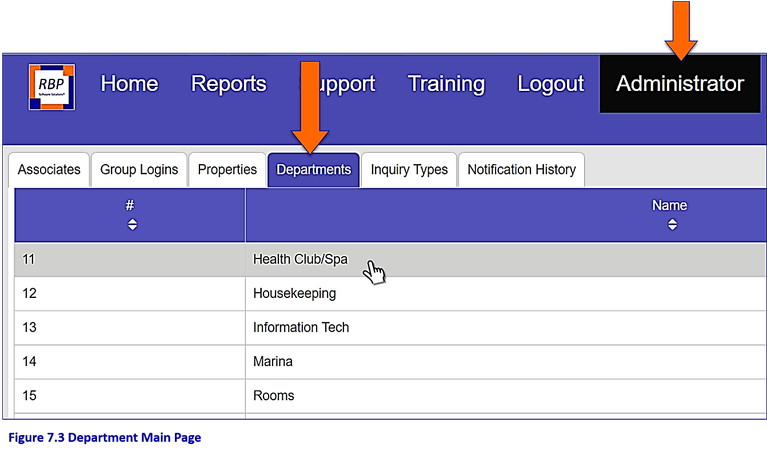

**Figure 7.3 Department Main Page**

Finally, for **Step 3**, first ensure that the department "**Health Club/Spa**" is "**enabled**" "**for this property**" as shown in Figure 7.4:

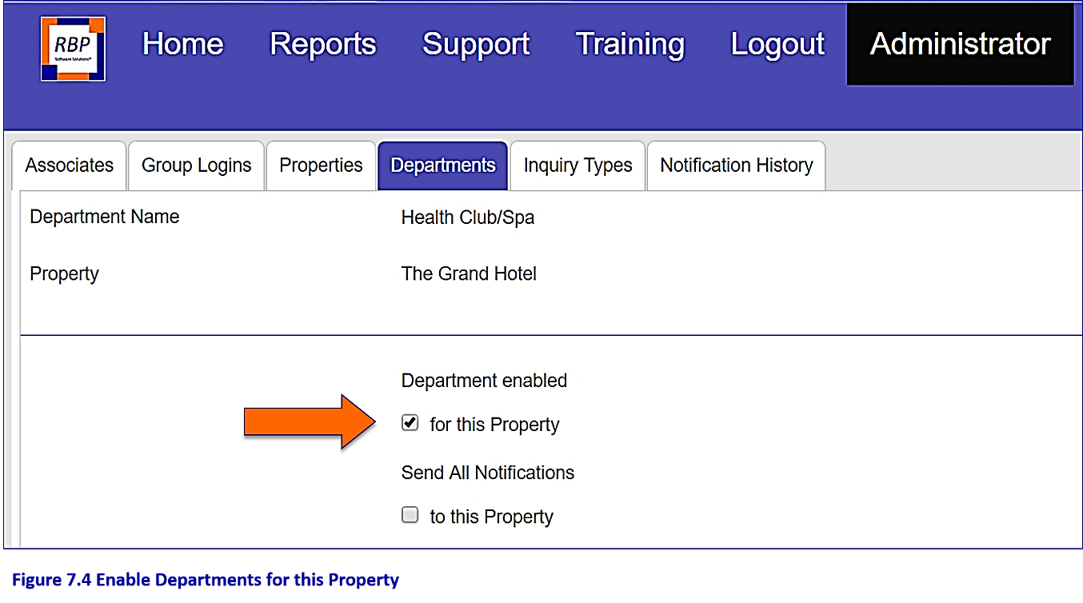

**Figure 7.4 Enable Departments for this Property**

You will also see a list of possible "**Department Contacts**". This list will include every Associate or Group you have registered into the system. You should now see the name "**Health Club/Spa**" in the list (it was added in Step 1 above) as shown in Figure 7.5. Select the "**Department Contact**" "**Health Club/Spa**" from the list by clicking in the box. Clicking this box will **attach** the contact information you entered for the Health Club/Spa in the "**Group Login**" to the Department.

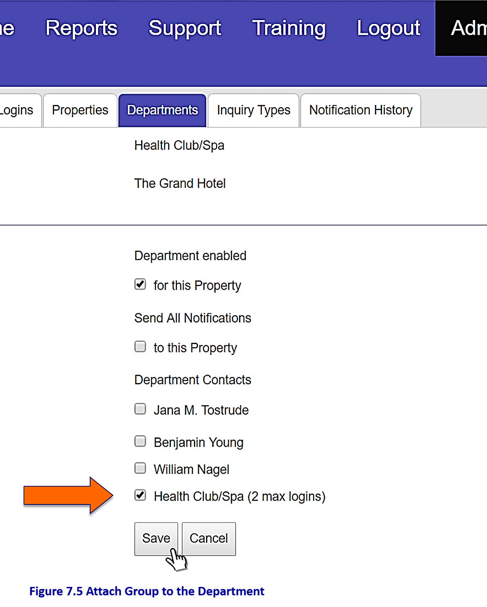

**Figure 7.5 Attach Group to the Department**

Click the "**Save**" button to save your changes and return to the Departments Main Page.

The Departments Main Page will now display the Associates or “**Contact Names**” that have been assigned to each Department as shown in Figure 7.6:

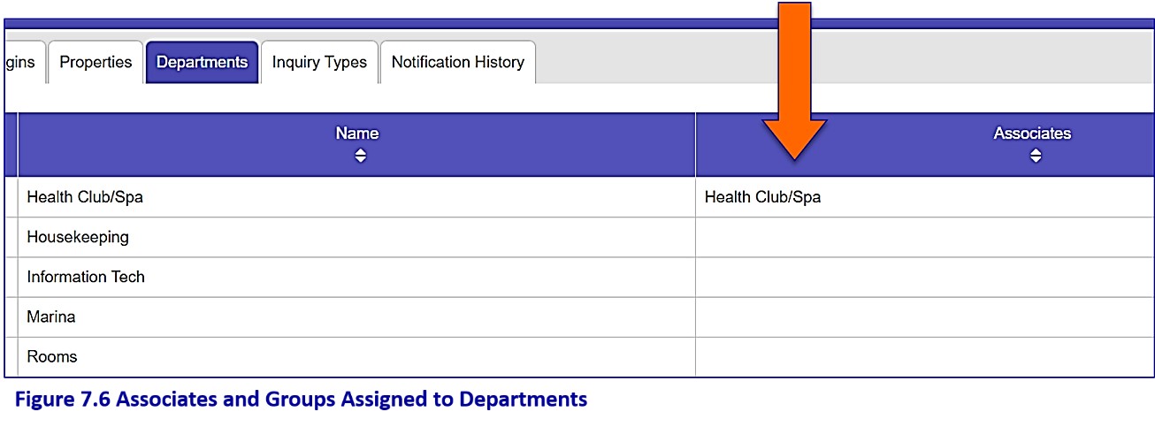

**Figure 7.6 Associates and Groups Assigned to Departments**

|  |
| --- |
| **NOTE** |
| For reference, we have included a list of Departments below in Figure 7.7. Note that if you do not set up a Department using these three steps you will not be able to send an internal communication to that department through the system. **REMEMBER:** Only “**Associates**” or “**Groups**” that have been previously set up in the Associate and Group Logins tabs will appear in the contact list for the departments. **To send an Internal Email, please review ‘Processing Inquiries’ in the User Guide Manual.** |

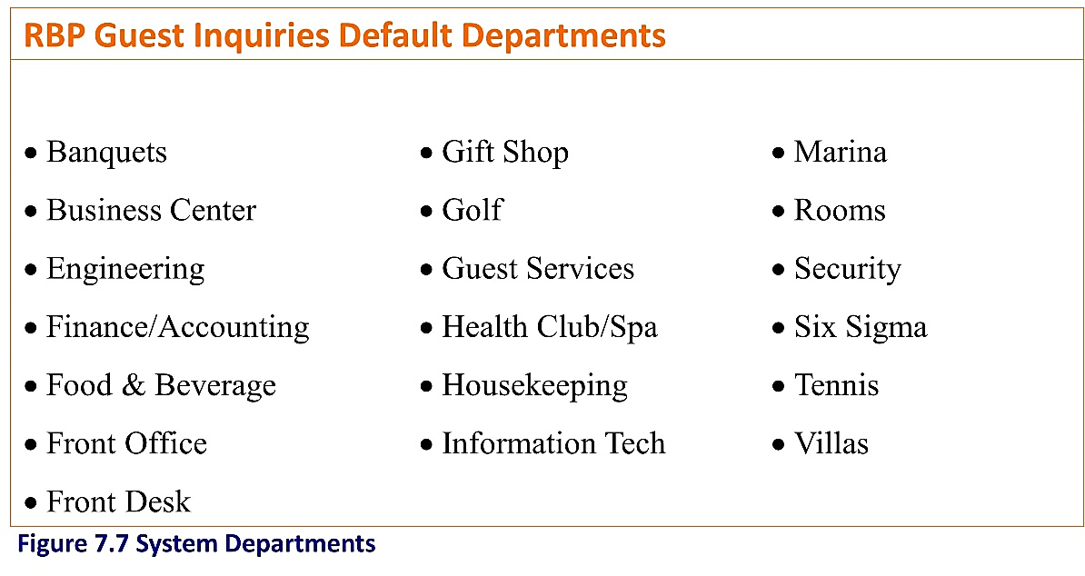

**Figure 7.7 System Departments**

Setting Up Approvalsin the System **(optional)**

RBP Guest Inquiries includes an option to set up an “**Approval Process**” within the system if desired. This structure is especially useful if the Front Desk or Guest Services is set up to process folios. The approval process revolves around the Credit Limit set up for each associate or group on the registration pages. **In order to close an inquiry a processor must have a credit limit higher than the refund amount requested on the inquiry**.

When every inquiry is "**closed**," the processor's "**Credit Limit**" is compared to the "**Refund Amount**" on the inquiry. If the Associate’s Credit Limit is **lower than** the amount of the refund, the inquiry will need to be approved and closed by an Associate with a higher credit limit. Default Credit Limits are displayed in Figure 7.8 below. **Folio and Refund Processor** Credit Limits are controlled and adjusted by the system Administrator only.

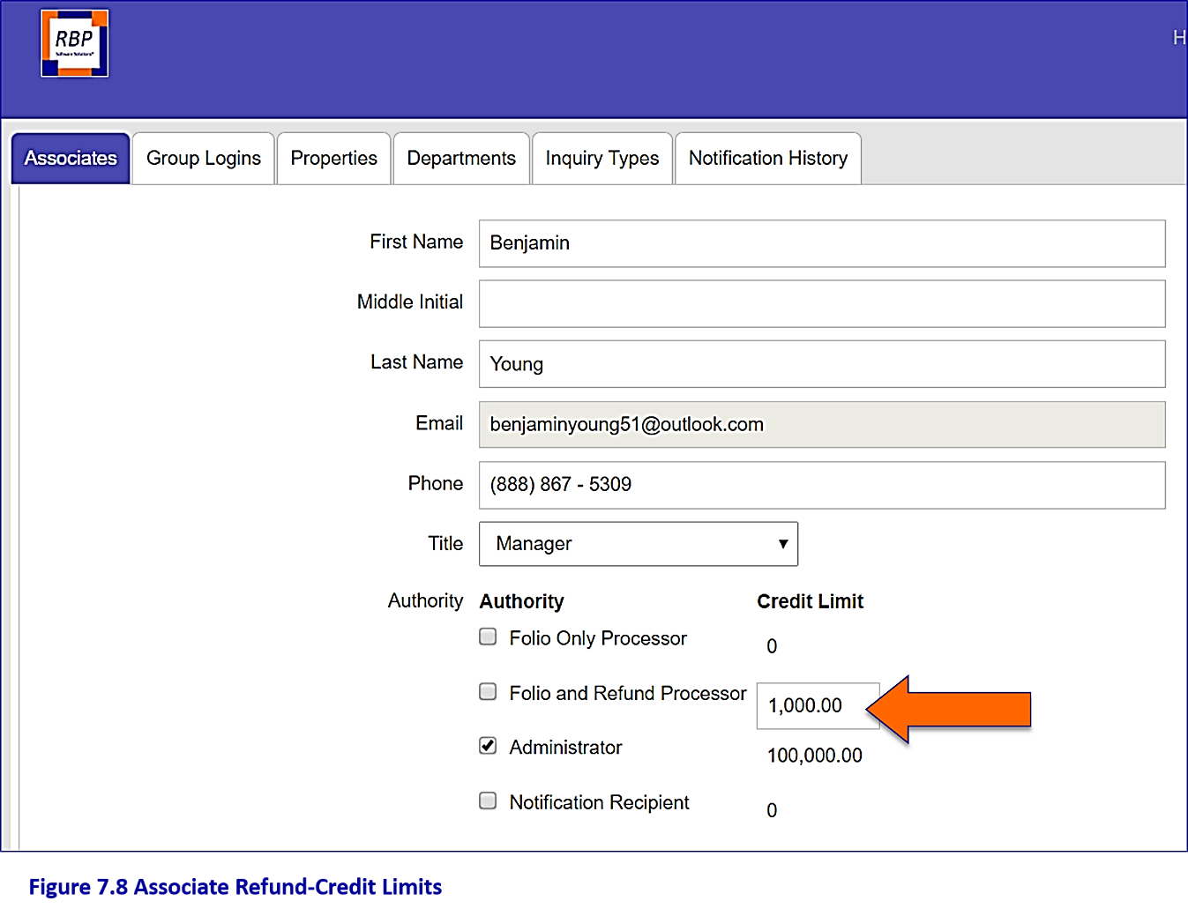

Figure 7.8 Associate Refund-Credit Limits

Credit Limit Examples

As mentioned, in order to close a ticket in the system, you must have a credit limit higher than the refund amount requested on the inquiry. Note that a “**Folio Only Processor**” has a credit limit of $0. This type of processor (i.e. a Front Desk person) is able to fully process (including uploading files, closing and sending the resolution email to the guest) only inquiries with a $0 in the refund amount box (i.e. only folios or receipt requests).

If a “**Folio Only Processor**” attempts to close a refund/credit, the inquiry will not close; instead it will be submitted to the “**Awaiting Approvals**” folder by the system. The system will then notify a processor with a higher credit limit that the inquiry needs approval. That person (the "**approver**") would then open the inquiry, complete processing, close and send the resolution email to the guest.

In the case of a “**Folio and Refund Processor**” we have set a default Credit Limit of $1,000. You may raise or lower this amount if desired simply by entering the new Credit Limit into the cell (and hitting “Update” to save). For a **Folio and Refund Processer** the approval process is very much the same as described above.

* If you (the Administrator) assign the processor a Credit Limit of $100 and a refund of $150 is processed (i.e. the associate’s credit limit is **lower** than the refund amount), that refund will need to be approved by someone in the system with a higher Credit Limit (say a Credit Limit of $200) before the inquiry may be closed and sent to the guest.
* In this case the inquiry will be sent automatically to the “**Awaiting Approvals**” folder on the Home Tab by the system and all associates with a credit limit of $150 or more will be notified by email that an inquiry is awaiting approval.
* If no associates in the system have a higher credit limit, the inquiry will go to the Administrator for approval.
* To close the inquiry, the "**approver**" would simply go the "**awaiting approvals**” folder and close the ticket as described in the **User Guide**.

|  |
| --- |
| **NOTE** |
| Only the Credit Limit for a “**Folio and Refund Processor**” may be raised or lowered. A “**Folio Only Processor**” always has a credit limit of $0 and an Administrator always has a credit limit of $100,000. |

* Also keep in mind that **when you set a Credit Limit in the system, that limit is for the associate only;** you’re not setting a Credit Limit for the Department.
* **Credit limits set here will not affect your general ledger system.**

The key when setting individual Credit Limits in the system is to consider the size of most of your billing inquiries and deciding how many of those inquiries you’d like to see go through the online approval process as it’s an extra step (we show you how the approval process works in the User Guide); the higher the credit limits, the fewer the number of inquiries that will need approvals.

Should you prefer not to implement the approval process simply assign all registrants to the “**Folio and Refund Processor**” authority and leave the Credit Limit amounts at $1,000 (you may also raise them if desired).

* In this case if a refund request of great than $1,000 is submitted to the system, the approval request will be submitted to the Administrator (and in this case the Administrator probably would want to see this inquiry anyway. If not, simply increase the credit limits to an amount higher than $1,000).

RBP Software Solutions

That’s all there is to setting up and customizing RBP Guest Inquiries!

RBP Software Solutions has developed a suite of Guest-Facing Technology Solutions. The cloud-based environment allows online communication with guests. The Company has partnered with Hotels Worldwide to implement solutions at individual properties. Please visit www.RBPsoftwaresolutions.com to view additional solutions, training materials, and property log-in portals.

Our Commitment to Customer Satisfaction

Customer satisfaction is our number one priority. At RBP Software Solutions we're confident in our ability to provide high quality service to you and your operation. Over our years of service, we have built a reputation for excellence by providing customers with quality product offerings and support. We're proud to be the only trusted Guest Inquiries Solution for the most beautiful and prestigious properties in the world. Should you have any questions please don’t hesitate to contact us by phone or email.

Contact: Jana Tostrude

Phone: 415-794-5262

Email: [support@rbpsoftwaresolutions.com](mailto:support@rbpsoftwaresolutions.com)

